J.E.M. Taylor, MD
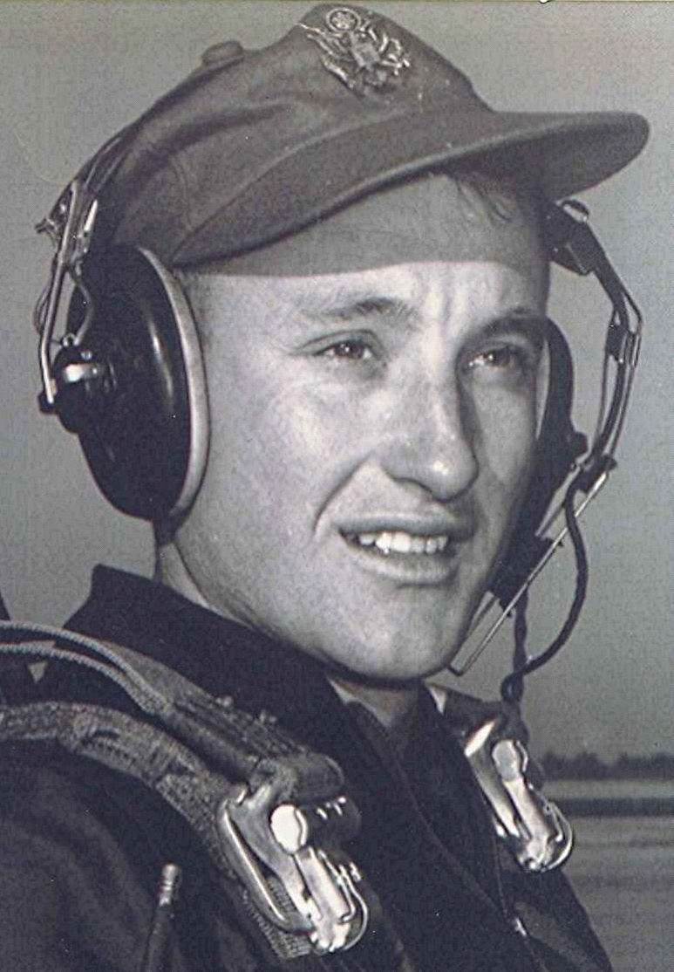
Memories of Dallas County
Notes and Other Unsubstantiated Opinions
where doctors made house calls
Date unknown
I remember the smell of medicine in Doctor Taylor's office in Sparkman, that also served as a drug store. His examination room, although it wasn't called that, had no closed doors, just openings into the small room, where those waiting out in the drugstore could overhear the conversations between doctor and patient.
I recall that when I was a child and Doctor Taylor came to the house to see me, his hands were always cold, not realizing till much later that it was because of my fever. Bald and ruddy of complexion, he spoke with a forceful but slow and resonant voice, unmistakable as to its owner. One could suppose that came about because of hearing loss and of having to speak loudly to his older, near-deaf patients. Although she was not a nurse, Mrs. Taylor would help sometimes. And Doctor Taylor gave his own shots and did all the bandaging and setting and everything else. Gave me a shot one time that caused pain to resonate from the tips of my fingers all the way to my shoulder socket and on beyond. Lord knows where that particular nerve ended.
This country doctor was perhaps the last of the last. Part of a vanishing group whose remaining members retired or died not too many years afterward. Rough and sometimes gruff, but beneath that exterior was a heart of gold. One who never refused to go see a patient, even when he must travel miles to get there and even when he knew that his bill would not be paid. Although gone from the state at the time, I later learned that they held a "Dr. Taylor Day" to honor the beloved physician who had been present when a significant percentage of the population of Dallas county came into the world. He wasn't a wealthy man by any measure, except that he was, in all likelihood, the most singularly respected and admired man in that part of Arkansas.
Editor's note: see Richard Boyd Dodson 015 ~ when doctors made house calls = tells a similar but slightly different view of this memory.

