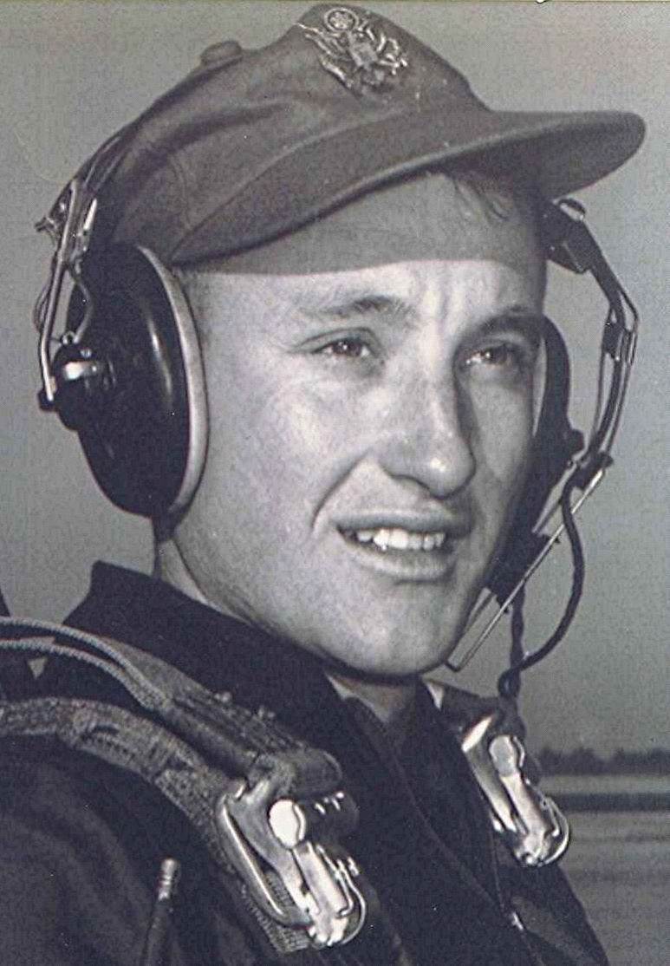
Memories of Dallas County
Notes and Other Unsubstantiated Opinions
Thanks to Them
Date unknown
On quiet nights I sometime drift off into a reverie of thoughts of where I came from and the influence that it had on my life. These memories of former times may be driven in part by all that is taking place today, when our society seems to be on a down-hill slide toward a future that I don't want to even contemplate. It is of little wonder then, that some of us think warmly of simpler times and places.
In that regard, the influence that Holly Springs and Sparkman had will remain with me till I draw my last breath. Among the principles that my parents and others tried to live by back there were: Work hard, give an honest day's effort, and treat others as you would have them treat you. And above all, be true to your word and faithful to the Creator who brought you to that place and time.
In the years since, while traveling around the world and associating with folks a lot smarter than me, I have never seen a circumstance where the simple philosophy of my folks and the ones who taught me at Sparkman didn't ring true. Sure, there were times when I tended to forget that training and my upbringing. Out there was a sophisticated world of wheeler-dealers and con artists who could charm the coconuts out of the palm trees. But thank goodness those transgressions were temporary and I, like another prodigal who wandered far from home, would be reminded of the place from where I came.
Some of my warmest memories are of being with those whom fate brought together at Sparkman High School.¹ There, the courses were very basic. Some might even call the education we got there inadequate but I will never believe that—too many good things flowed from my time there. We were taught to play fairly and respect others, regardless of their station in life. Besides that, being products of the depression, most of us were from households of very limited means, therefore having little about which to be overly proud or conceited. Looking back, I don't see that as being deprived. Quite the contrary…
Becoming a good citizen and voting was emphasize as being of paramount importance. Those who knew superintendent Dwight Wilkins will probably remember his lessons in civic responsibility. On that, he was practically a "Johnny one-note." But if he intended those lectures to stick in our minds, he succeeded in at least one case, mine.
What is Sparkman High School like today? I cannot answer that, and, to be truthful, would really rather remember what it was back then. Sadly, not much remains from my days there to remind us of those times; evidence of how transitional and temporary are the physical things in this world.
Our experience back there burned brightly for us, but in the terms of time and eternity, it was only for a brief and fleeting day. Then, like the flare in the night, it too disappeared into the gloom of history—except for that which we keep alive within our memories. I am grateful for having been granted the blessing (God's) of growing up when and where I did; and for the privilege of sharing that part of my life with those who were there with me.
1 ~ For those of you who don't know it already, a small group from my class (1951) keeps returning for a weekend together each fall where we renew the friendship we have shared across the years.
[Editor's note: Holly Springs and Sparkman, both of Dallas County, Arkansas, USA]

