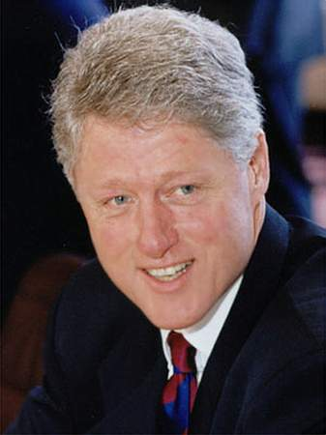
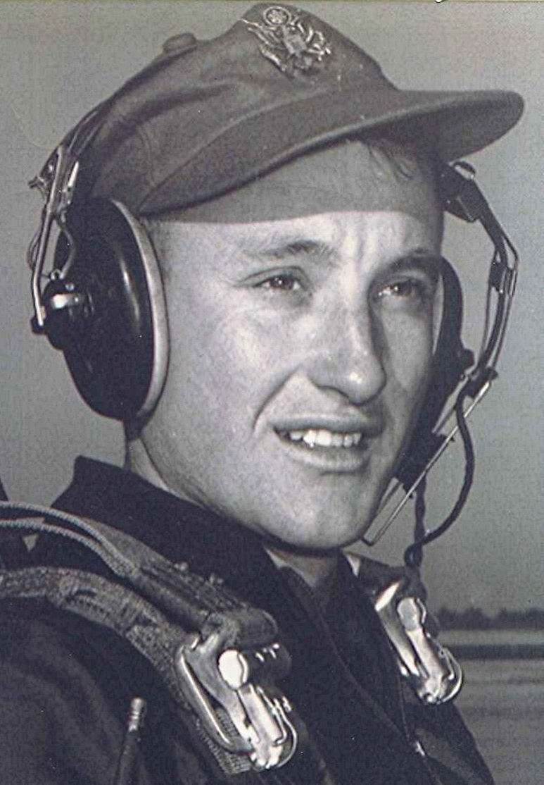
Letter to the Editor Bill Clinton
(From Way Back)
Date unknown
The jokes are rolling in about Arkansas. The latest being that Clinton's DNA couldn't be identified because everyone's (in the state) is the same. Such dark humor has a strain of reality, given the considerable number of years the First Alpha Male roamed the tundra of our provinces.
I suppose we could or should harbor some resentment at being the butt of these jokes, but then it seems to me that we asked for it. The people around Clinton and even the local media types who observed and wrote about him all those years surely must have had some clue, some insight into his character, or lack thereof. Apparently such perspicacity was too much to ask. This evidenced in the case of one Little Rock columnist, who in spite of a terminal case of intellectual vacuity, is still employed there. Clinton's aura was so powerful that he apparently swooned in the presence of, as he put it, "the light of the Sun King." The only conclusion I can come to is that being near the source of power, whether real or perceived, induces a numbed sense of values and in this case, sensibilities.
Even now, with Clinton having admitted to lying to the nation publicly, emphatically, and with locked-jaw certitude, the true believers are dismayed that some of us may be unwilling to overlook such a minor "error in judgment" as he characterized it. Friday night on AETN some of the Clintonite members of "Arkansas Week" looked as if they had just come from the funeral home after reviewing the body. One of these true-believer loyalists still insists that Clinton's lying is no big deal, especially when compared to Nixon's bombing of Cambodia. Nothing like an historical non sequitur to deflect attention from the issue. Hearing that inanity, I said to my wife, "Well, the last dog ain't yet died."

