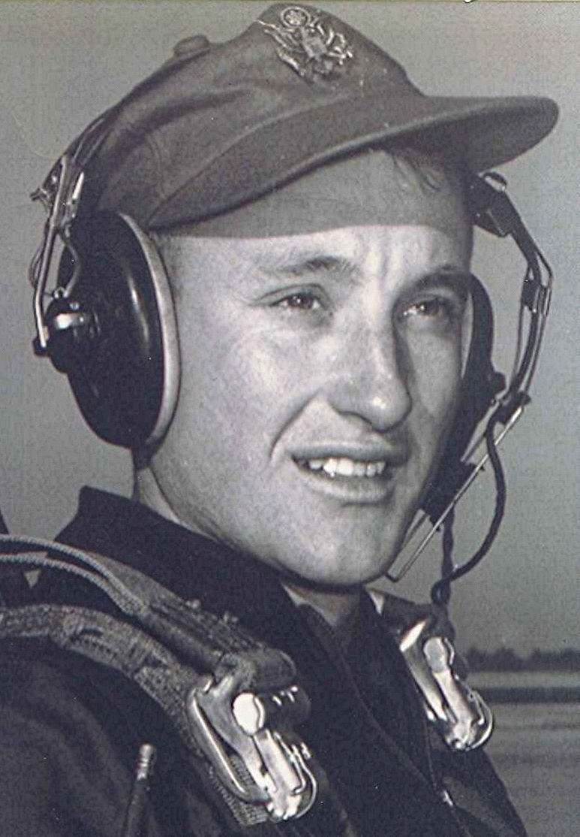
Class of 1951
Notes and other unsubstantiated opinions
Prophecies and Predictions
At first glance it would be difficult to see any benefit from being in the throes of upper middle age and facing the onset of senility, but it provides an opportunity to think about "what-ifs." What if we could see into the future, as our class prophesies pretended to do? Thinking back over all that has happened, I realize it is a blessing that God, in His infinite wisdom, denies us any knowledge as to what may happen to us tomorrow. In spite of that unknowing, and maybe because of it, I have an urge sometimes to turn around in the middle of the road traveled and go back. But the realities are that there can be no turning back, no rewriting. A great philosopher, poet, and saint said it splendidly in King James:
This one thing I do, forgetting those things which are behind, and reaching forth to those things which are before, I press toward the mark of the high calling of God in Jesus Christ. ¹

1~ Philippians 3:13-14

