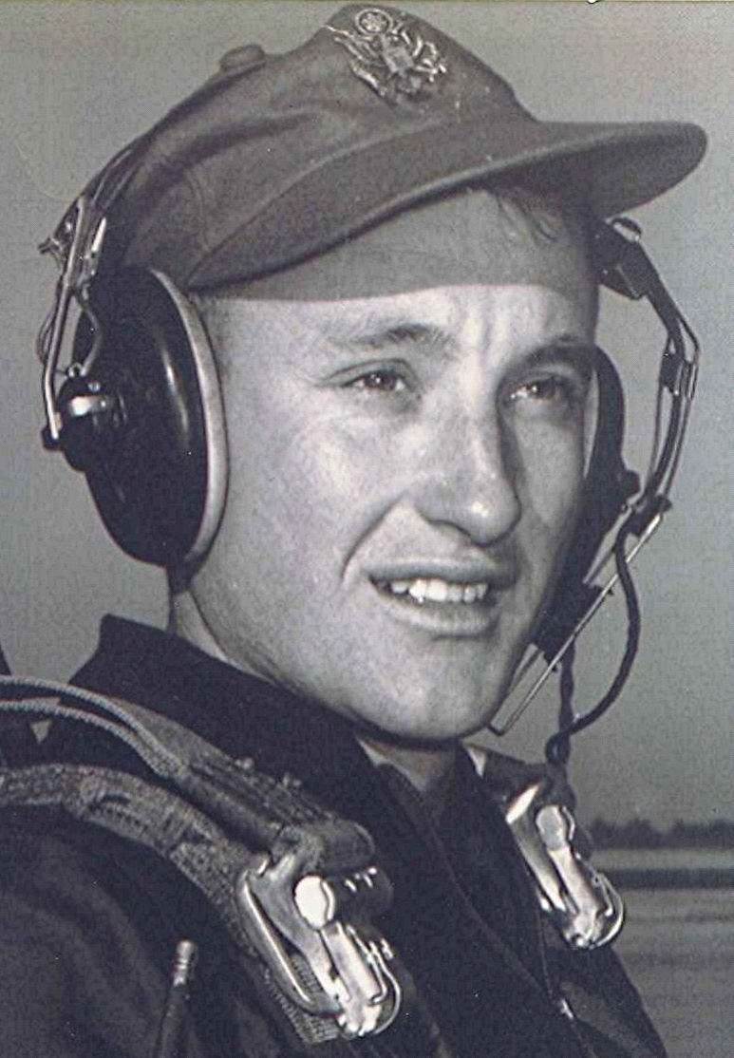
In the mind's eye
Personal Notes and Other Symptoms of the Onset of Senility
On Reaching Seventy
August 10, 2003
I remember reaching the age of forty and the impact it had upon my life.
At that time I recalled hearing Harry Reasoner some years before on the CBS evening news talk about turning forty. How all those things that up to then were possibilities, though remote, and how reaching the age of forty brought one up against the stark realization that they would never be.
At the age of forty I knew that I would never be a major league baseball pitcher, a surgeon, a writer, or an evangelist, to name a few. All those things once entertained as possibilities were not to be, once that point of demarcation on life's time-line had passed..
The adjustment to these realities took some time and a lot of rethinking about a lot of things. Gradually, the age of forty didn't seem all that bad anymore. In fact there were times when I actually felt well, like maybe thirty-eight! I took up running as a hobby while in Vietnam and pursued it daily until it became an addiction. In the process so much weight was lost that the alterations by the Vietnamese tailors on base caused the rear pockets on my civilian pants to meet in the back. This result was a source of amusement for Jane¹ when we met in Maui for R & R in the spring of 1971. The running continued on through the years until brought to a crashing end with a broken femur.
Somewhere in the intervening thirty years between forty and seventy, a period of resignation set in and the disquiet over opportunities gone by or dreams unfulfilled subsided. I cannot name the day or the hour when all that happened. In its place came an acquiescence of sort, an acceptance of the reality of the passing years; each increasing in brevity and speed. To the point now that one hardly gets used to writing the year's date on the check book until it is time to learn new one.
Which brings me back to where I started out: reaching seventy. The scariest thing about that anniversary is to think back over, say, the past fifteen or twenty years and contemplate how quickly it all passed. It seems hardly longer than a quiet Sunday afternoon, doesn't it. Taking that same brief interval and projecting it into the future brings us up against the harsh reality that at some time in that remaining brief period, most of us will no longer be.
One thing is for certain, we most assuredly know something we didn't know before: that our remaining days are now within a narrow definition, something that we didn't know back there at forty, except that statistically, our lives were probably half over then. But that was a glass half full or half empty, whichever description we chose.
Having said all that, it seems to me that becoming seventy presents several opportunities. For one thing it gives us a better perspective on what things are important and those that are not. For example, one can view an endless succession of consumer goods advertised on TV and know that there isn't a single thing that inspires us to run out and buy it or even want it, for that matter.
And we know better when those intelligence-insulting advertisers insinuate that drinking a certain beer will insure romance and success. Ditto for shave lotion, toothpaste, and others, the list extending to ad nauseam. Which also leads me to the conclusion that there must be little demand for cotton if the scantily clad subjects prancing around on the screen are any indication of the dress habits, current and future.
But then one could ask what does a soon-to-be seventy year old know about anything except aching joints, atrophying muscles, those weekly pill boxes with the large letters and lastly, our failing memory. In a society where youth is god and "old" is deemed to merit only a place in God's Waiting Room in the nearest nursing home, probably not much.
I have talked of "first things" before and the fact that being where we are gives us a special perspective on what is really important in life. The refractive characteristics of the atmosphere at sunset divert all the colors except red off into the universe, leaving us with some breathtakingly beautiful sunsets.
Such, I believe, are the refractive effects of advancing age, where one comes to divert all the meaning-less considerations, leaving only those that really matter during this short journey on earth.
The recent death of a friend's Mother at the age of 93 is probably the genesis of all this incoherence and babbling. He, the son, mentioned how his Mother spoke of being lonely after losing her husband and all the rest of her siblings, she being the last remaining one.
I have probably mentioned before the undesirability of living beyond a hundred; or even reaching a hundred for that matter. First off, most of ones contemporaries, those who shared a common history, knew about and shared stories, myths, and experiences will have been gone. It seems to me to be appropriate to liken such a thing to one wandering around a deserted high school yard after the busses have departed with all their school mates, taking them home. She has now joined them once again.

1 ~ Editor's note: Jane Rhea Lancaster Dodson, his wife

