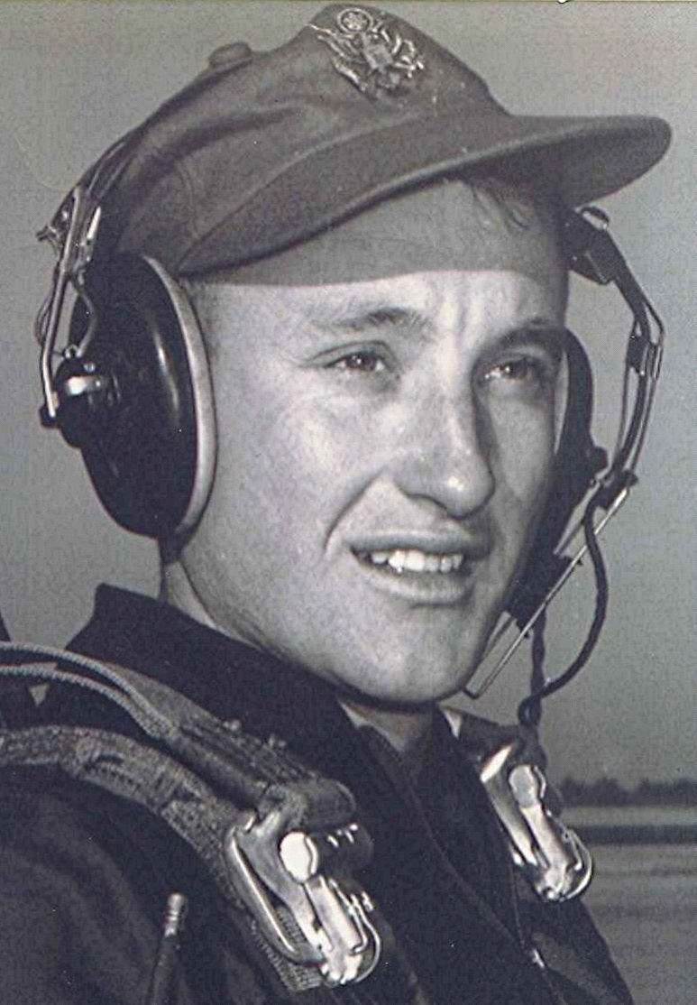
Class of 1951
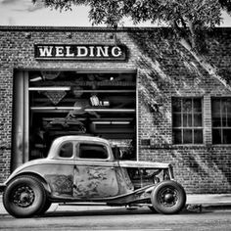
The Squatleys and their kinfolk
October 15, 2002
My seventy-some year old friend Joe has lived in Dyer most of his life and has lots of stories about the citizens of the town back when times were hard. One, who shall remain nameless other than "Dick," owned and operated a ferry across the Arkansas River which is about a mile south of town. He also had a house full of boys, some named for an important historical figure. Joe lists their names as: John (Bunt), Thomas Edison (Bud), Oscar Madison? (Oss), Benjamin Franklin (Ben), Richard (No nickname), Martin Luther (Tooter), Edgar (Pussy Foot). Joe goes on to relate the "Car Story"…
"Since Dick had the mail contract to set the mail across the river to Arbuckle Island in conjunction with his ferry business, he received the grand sum of $50 per month from the Government. This along with the proceeds from his ferry operation allowed him to purchase a purty late model car which he turned the boys loose on with their grubbing hoes, chopping axes, and other available tools and VOILA! - An instant pickup truck in which they could all ride to the river."
But Crawford County doesn't have a monopoly on native ingenuity, self sufficiency, and even optimism. Once, years ago, while living in North Little Rock I drove behind a dilapidated old Buick with faded paint and a rusted-out body. Its top manifested only the shredded remains of what was once a vinyl roof. It looked like it had been parked under a Chinaberry tree where the chickens roosted. Piled high in the back were odds and ends of every sort: old clothes and other junk. On the rear bumper, a faded sticker that read "Living is Great in North Little Rock!".

