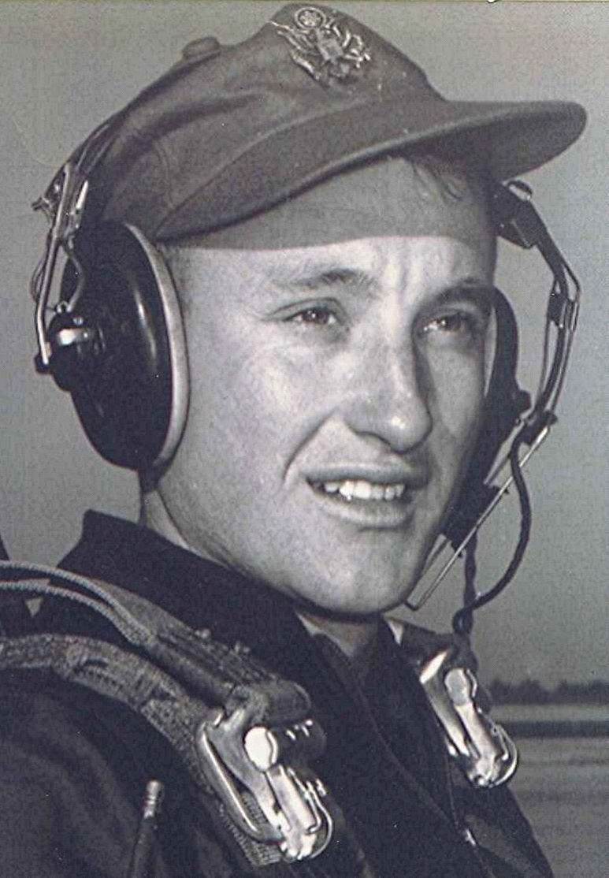
Class of 1951
For Your Consideration
October 15, 2002
While driving along behind a Fort Smith car this week I noted that it had one of the local fixes that enables some of us to continue to use a car while avoiding insurance premiums or garage bills after being in an accident. What it was, was a demolished left rear tail light and turn signal, one of those rather large ones relative to the size of the car. The owner had covered the shattered light with a dense tape, red in color to match the missing glass but with one serious drawback - no light could penetrate the tape. It looked fine until the brake lights came on and the absence of any rays, red or otherwise, revealed the fake.
DON'T PUT YOUR ARM
OUT THE WINDOW TOO FAR
OR IT'LL RIDE HOME
IN ANOTHER CAR
~ Burma Shave
Following a car with no turn signal or brake light on that side reminded me that not too many years ago, there were no such things as electric turn signals. That and the Burma Shave rhyme sent to me by Merlie Watson. It recalls a time when folks stuck their arms out as far as they felt they could do so without them being struck by an oncoming car. Remember how an arm and hand extended straight out the window meant you planned to turn left (I think the index finger was supposed to point toward the way you meant to turn). When a right turn signal was your arm extended straight out to the elbow, then a ninety degree bend till the hand is straight up toward the heavens. I think it helped to again use the index finger to point to the right, up over the top of the car, truck or whatever. An arm straight down beside the door with the palm turned toward following traffic indicated you intended to stop someplace ahead.
All of which brings up another question: are hand signals still legal and, if so, can you be given a ticket for inoperative turn signals if you use the aforementioned arm and hand instead? Does the Arkansas drivers' license written examination cover hand signals? Last one I saw did, but that was a long time back. That was when I was about fourteen or so and took my driving test in a ton and half cattle truck with vacuum boost brakes that almost threw the State Police examiner through the windshield. I still remember the look on his face when he asked where my vehicle was and I pointed out the big truck with the dual wheels and cattle rack parked at the curb. I passed the driving test but he graded points off for poor braking technique.
I never thought about it before, but the advent of air conditioning must have been what prompted the requirement for electric turn signals. The old cars and trucks often only had one tail light and it was a dim one too. But that's not too different from some of the local vehicles we see in Crawford County, with shattered rear and side windows covered with garbage bags and duct tape. Sometimes Saran Wrap or other clear plastic is used when one needs to let light in or see out. I guess that beats the heck out of paying a garage bill. Duct tape is great stuff for making repairs, especially when combined with a heavy duty garbage bags.
Wading in the shallow end of the gene pool
In Crawford County a daughter informed her mother she was pregnant. To which her mother responded, "How do you know it is yours?"
~ Stolen from the Lucianne.com web page

