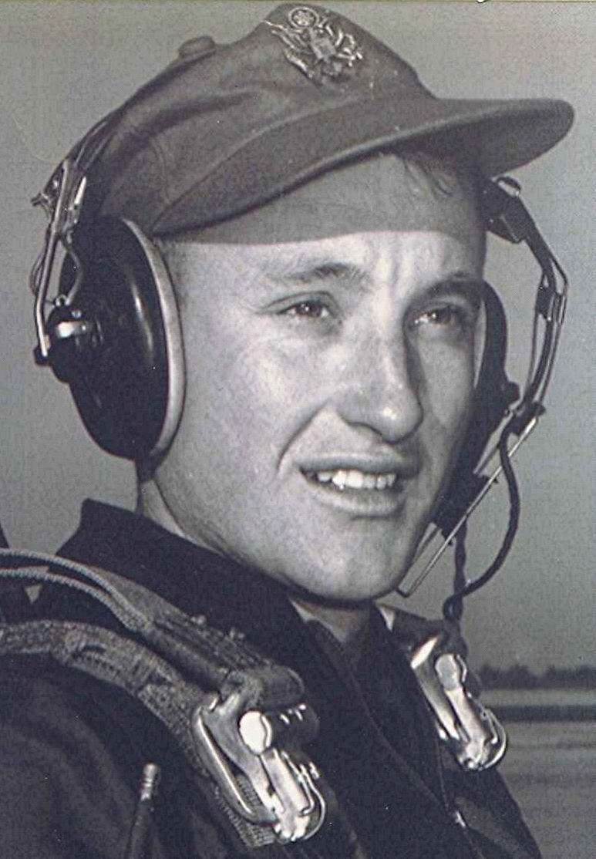
In the Mind's Eye
Honey
Artist: Bobby Goldsboro
Bobby Goldsboro
Was # 1 for 5 weeks in 1968
01 October 2001
See the tree, how big it's grown but friend it hasn't been too long it wasn't big
I laughed at her and she got mad, the first day that she planted, it, was just a twig
Then the first snow came and she ran out to brush the snow away
So it wouldn't die
Came runnin' in all excited, slipped and almost hurt herself
And I laughed till I cried
She was always young at heart, kinda dumb and kinda smart and I loved her so
And I surprised her with a puppy
Kept me up all Christmas Eve two years ago
And it would sure embarrass her
When I came in from workin' late 'cause I would know
That she'd been sittin' there and cryin'
Over some sad and silly late, late show
And honey, I miss you and I'm bein' good
And I'd love to be with you if only I could
She wrecked the car and she was sad
And so afraid that I'd be mad but what the heck
Though I pretended hard to be
Guess you could say she saw through me and hugged my neck
I came home unexpectedly and caught her cryin' needlessly
In the middle of a day
And it was in the early Spring when flowers bloom and robins sing
She went away
And honey, I miss you and I'm bein' good
And I'd love to be with you if only I could
One day while I was not at home while she was there and all alone
The angels came
Now all I have is memories of Honey and I wake up nights and call her name
Now my life's an empty stage where Honey lived and Honey played
And love grew up
And a small cloud passes overhead and cries down on the flower bed
That Honey loved
And see the tree how big it's grown but friend it hasn't been too long it wasn't big
And I laughed at her and she got mad
The first day that she planted it, was just a twig

