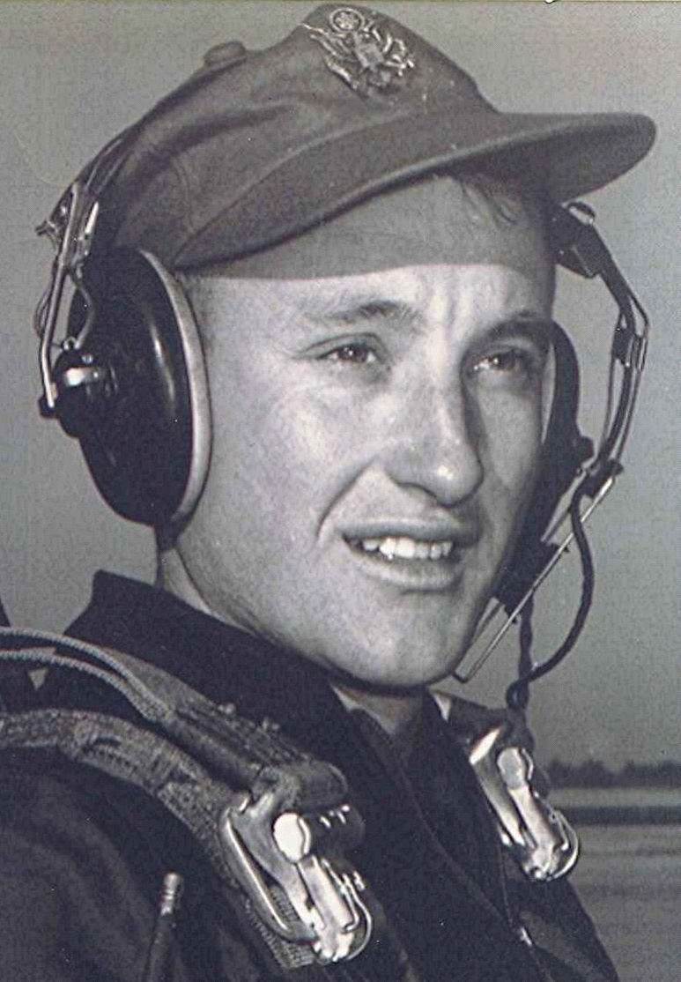
In the Mind's Eye
My Final Words on Eddy Arnold
(I Promise)
01 October 2001
A couple of weeks ago, I heard from someone in Spring, Texas. He had seen my name on an Eddy Arnold guest book on the Internet, in which I had written how Eddy was my favorite singer back in high school. He sent me a tape of some radio broadcasts from way back. Amazing, while listening to a bunch of songs I hadn't heard in over fifty years, how the words still reside in the corridors of memory. I duplicated the tape and sent it on to a couple of Eddy's fans my age.
Eddy was the son a sharecropper and the memories of poverty stayed with him through his career. He once stated he had part of the first dollar he ever made. Another story goes that someone asked him how much property he owned. When he said "forty acres" they asked where it was. He replied, "Downtown Houston."
In addition to the gentleman from Spring, Texas, I have met others through the Internet because of our mutual interest in old farm tractors and 1949 Chevrolet Pickups. Don't know about you, but recent events have made my memories of the "Good ole Days" even more significant.

