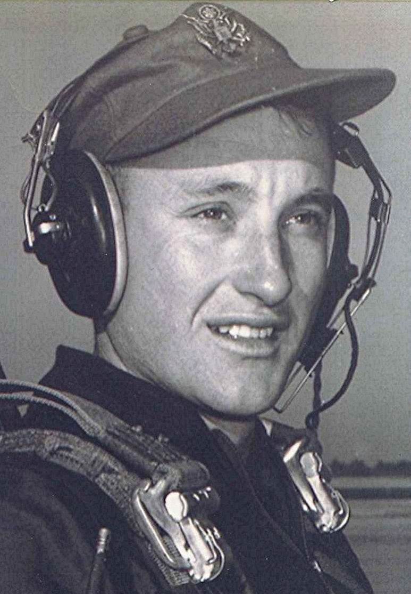
In the Mind's Eye
October
01 October 2001
Hard to believe that October is here, but as the saying goes, "Time flies when you are having fun." Well, not really. However, the turning of the calendar offers us a chance to retreat, if only momentarily, from the momentous events of September and take stock of where we are and what we are all about. There have been thousands, probably millions of words penned since Sept 11, 2001, and I won't be so presumptuous as to try to add anything to that accumulated wisdom.
I will however, point out some things that don't seem nearly as important now as before. Not that I ever put much stock in who won a baseball or football game on any given afternoon, but nothing could be more irrelevant to our lives over the past two weeks. Thankfully some in the sports world recognized that fact and voluntarily cancelled numerous sports events. Even the retired world's greatest basketball player's announcement that he would be returning to the game raised little interest. Maybe we are finally getting our priorities straight.

