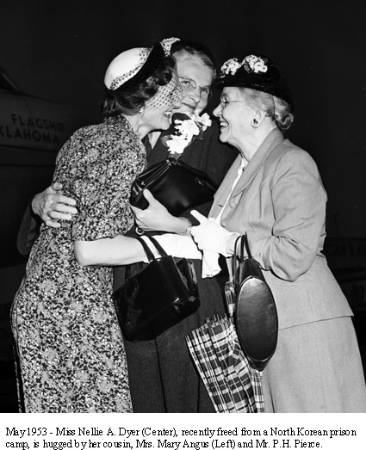
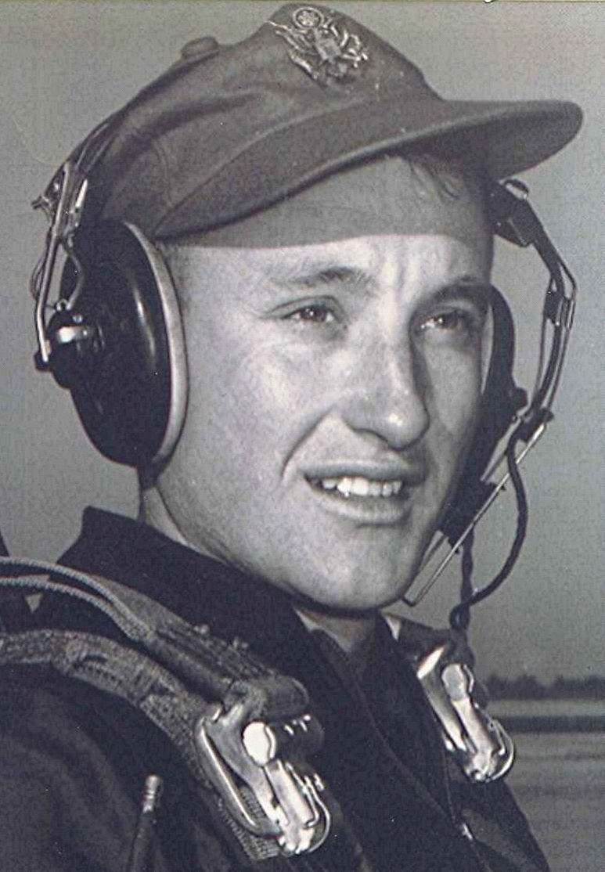
In the Mind's Eye
Of Heroes and Common People
Nellie Arkensau Dyer, former missionary and prisoner of war, dies at 97
13 September 2000
The above headlines, taken from the United Methodist News Service, do little toward explaining the remarkably heroic life of a family relative. When Miss Dyer died on January 23, 2000, in Joplin, Missouri, the Kansas City newspaper’s obituary was about four lines long. It stated the date of her death and that she was a “teacher”. Her remarkable life could be the basis for a full length movie, reminiscent of “The Bridge on the River Kwai”.
She was born in Van Buren, [Arkansas], and graduated from Galloway College, after which she attended Scarritt College for two years. At Scarritt she trained for missionary work. Afterwards, she taught English in the Holston Institute at Songdo, Korea for 12 years. She was studying Japanese at the University of Japan in October, 1941, when, because of the threat of war, she was given a missionary assignment in the Philippine Islands. She was captured by the Japanese in 1942 and was held prisoner in an internment camp until liberated in March, 1945.
Two years later, after receiving an M.A. degree from Northwestern University, she returned to Korea with, as she expressed it, “a deep sense of mission “ She was stationed in a town near the North Korean border which was overrun at the beginning of the Korean war on June 25, 1950. Again she was taken prisoner—this time by the North Koreans. In November 1950, she was in the Death March in which the North Koreans force marched their prisoners into Manchuria, where she and others endured unspeakable privation until their release in April 1953. She returned to Arkansas and taught in North Little Rock until her retirement in 1967. She moved to Joplin MO, in 1989 and lived there until her death in January.
Miss Dyer surely occupies a unique place in our country’s history, having been a civilian prisoner of war in two conflicts for a total of five years. Unfortunately (for us) she apparently wrote little about her incredible experiences. There is a copy of a letter she wrote while on the plane returning to this country after her release from captivity in Manchuria. Sadly, I have misplaced that letter, which tells of the hardships she and others endured at the hands of the North Koreans. Surprisingly (to me), she was far more critical of her Korean captors than she was the Japanese.
[Nellie Arkensau Dyer is my 1st cousin 1x removed ~ Thomas Irl Lancaster.]

