Stonewall Jackson
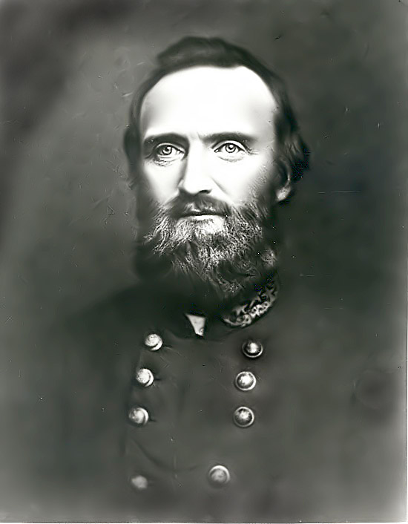
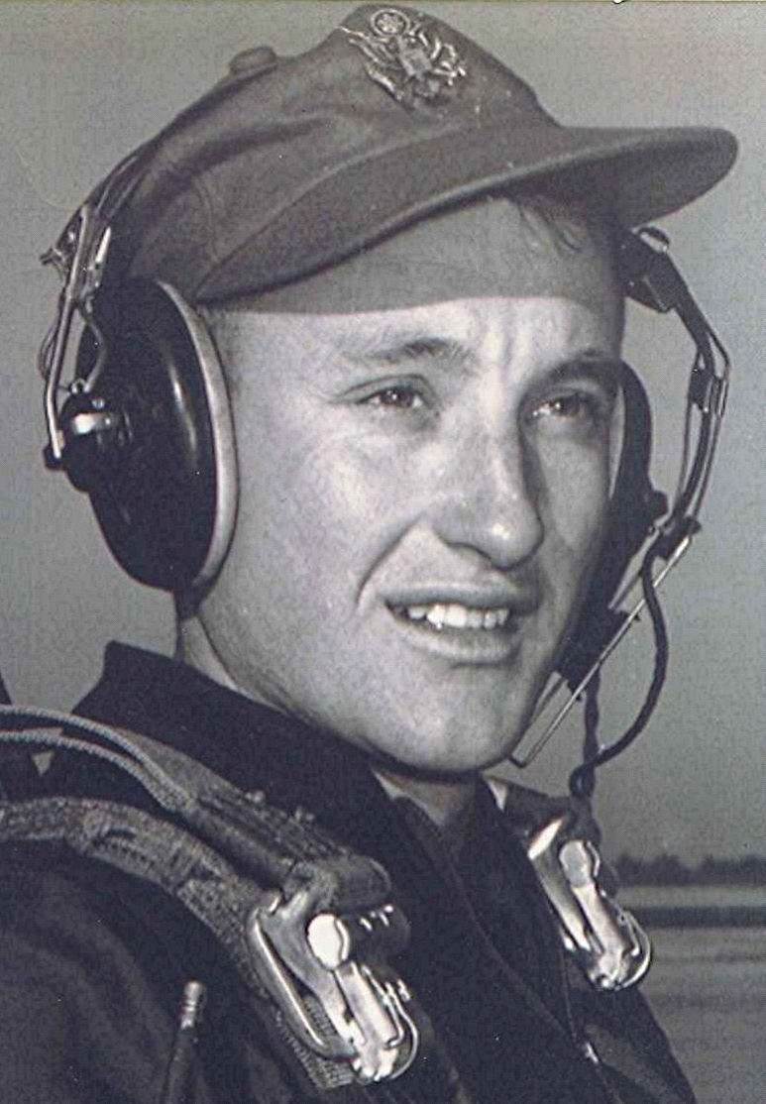
In the Mind's Eye
Of Heroes and Common People
A Southern Hero in Life and Death
13 September 2000
"Let us cross over the river and rest under the shade of the trees."
We read and talk from time to time, about heroic moments when facing death. And that brings to mind the Confederate general, Stonewall Jackson, who was mortally wounded by his own soldiers’ gunfire at the battle of Chancellorsville, Virginia. He lived eight days after the day he was shot. His left arm was amputated on the battlefield by the attending field surgeon. He sustained several other wounds in addition to the arm. Afterwards, while lying on a mattress, they transported him 27 miles in a horse-drawn ambulance to a spot behind the lines. An officer was dispatched to Richmond to bring his wife and young child to be with him. He seemed to be doing well until about the fourth day when he took a sudden turn for the worse. Dr. McGuire, who had been with General Jackson the entire time since his wounding diagnosed his pain and breathing difficulty as being from pneumonia.
Within a matter of a day or so, his condition continued to deteriorate and it was determined that nothing further could be done. This, after another doctor whose specialty was pneumonia cases had been summoned and declared his condition beyond help. General Jackson conveyed to his young wife his wishes as to where he would be buried and what she should do in the best interest of their child. On Sunday morning May 10, 1863, Dr. McGuire informed Mrs. Jackson that the General would not last the day. His wife insisted that he be informed of this. At the end, when he was slipping in and out of a coma, his physician informed him that he would possibly only live a couple of hours. He replied "It is the Lord's Day; my wish is fulfilled. I have always desired to die on Sunday." Later that afternoon, his dying words were, "Let us cross over the river and rest under the shade of the trees."
Thomas Jonathan (Stonewall) Jackson was not a religious man for a goodly portion of his life. However, in the years leading up to the time of his death, he experienced a conversion and became a devout Christian. His writings and correspondence to other field commanders and subordinates are laced with references to God’s influence and guiding hand in his life. Before the Civil War he was a professor at Virginia Military Institute and his memory occupies a place of high honor among the cadets and graduates of that institution. The men who served under him were devoted to their general, and there was great anguish upon hearing the news of his death. Stonewall Jackson was General Robert E. Lee’s top field commander and, upon being told of his death, Lee wept openly. ¹
~ ~ ~ ~ ~
In 1975 Dr. Beverly Smith did a study of the facts as could be determined surrounding the death of Stonewall Jackson. She believes that his death was from a blood clot in his lungs and not from pneumonia. As diagnosed by the attending physician, Dr. Smith states that given the level of knowledge at the time, everything possible was done for the dying general. ²
1 ~ Information “paraphrased” is from Civil War Resources from the VMI Archives; Death of Stonewall Jackson VMI Alumni Review Article, Part 1
2 ~ “The Last Illness and Death of General Thomas Jonathan (Stonewall) Jackson”
By Beverly C. Smith, MD

"We should remember our dying and try to live that our death brings no pleasure to the world."
by John Steinbeck

