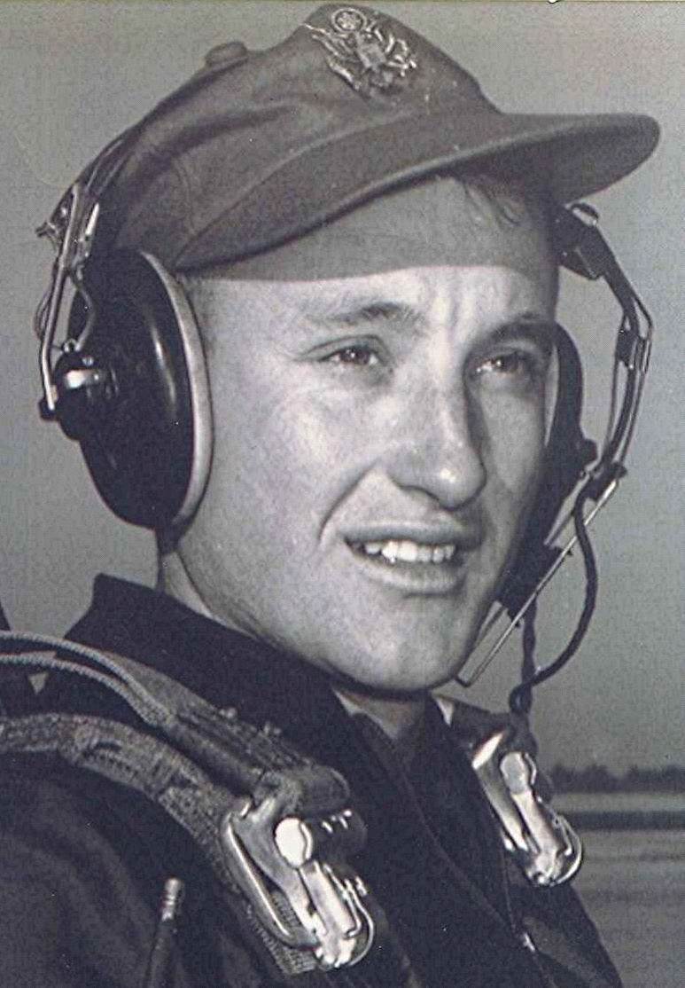
In the Mind's Eye
Of Heroes and Common People
The Sands of Time Slip Away
13 September 2000
Another of those who were with us at Sparkman last October has stepped across the threshold of the door to eternity. Pauline’s dear friend Paul Castleberry died Friday, the 1st of September, 2000.
Paul, Billy Poole, and Eugene Chittum all were at our meeting at Sparkman last October. Paul’s Funeral was at Camden on Monday. One of the most important things about funerals is they serve to remind us of our own mortality; a fact that becomes all the more apparent with each passing year.

The Seven Social Sins: "Politics without principles, wealth without work, pleasure without conscience, knowledge without character, commerce without morality, science without humanity, and worship without sacrifice."
The more or less honorable Billybob,
Cyber Congressman from West Carolina.

