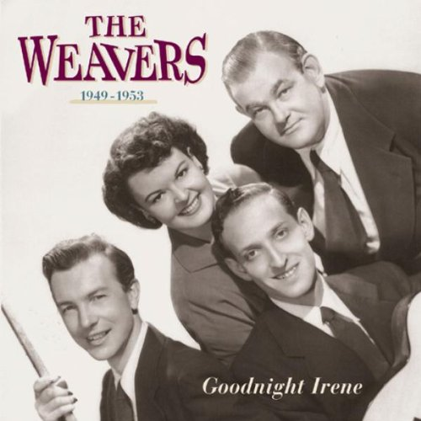
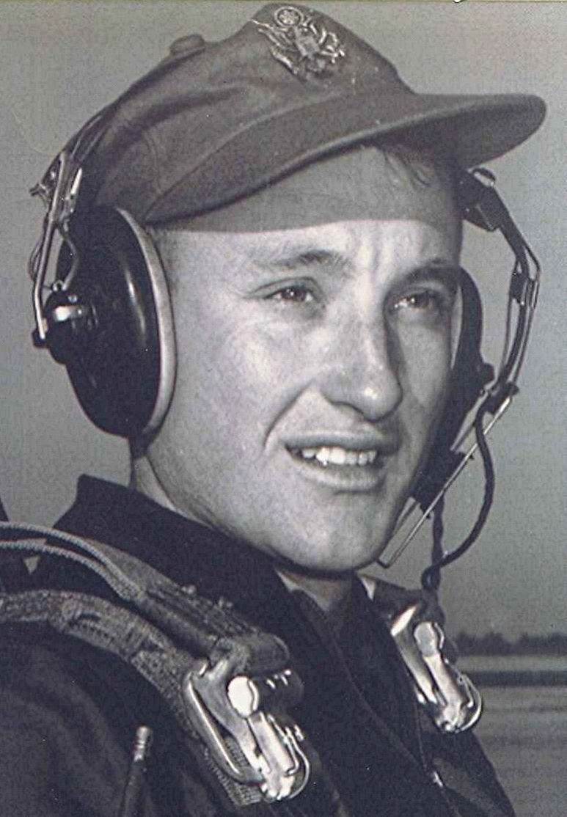
In the Mind's Eye
Or: Contemplating one’s navel can lead to severe neck strain
Here’s Another From Sometime Back Then:
Goodnight, Irene
23 July 2000
Gordon Jenkins & his orchestra & The Weavers
(chorus)
Irene, goodnight,
Irene, goodnight,
Goodnight, Irene,
Goodnight, Irene, I'll see you in my dreams.
Last Saturday night I got married,
Me and my wife settle down,,
Now me and my wife are parted, I'm gonna take another stroll in town.
(repeat chorus)
Sometimes I live in the country,
Sometimes I live in town,
Sometimes I have a great notion, To jump in the river and drown.
(end song with chorus repeat)
~ ~ ~ ~ ~
Under the Heading of Dull Trivia from the Dull Men's Club:
The term "the whole 9 yards" came from WWII fighter pilots in the Pacific. When arming their airplanes on the ground, the .50 caliber machine gun ammo belts measured exactly 27 feet before being loaded into the fuselage. If the pilots fired all their ammo at a target, it got "the whole 9 yards."

