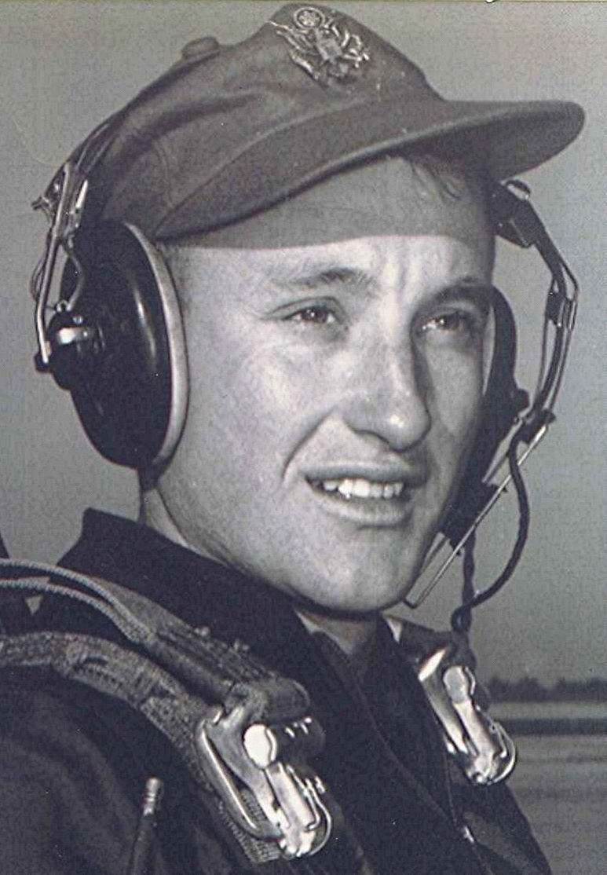
Considering the great questions
20 August 1999

When you are old and gray and full of sleep,
And nodding by the fire, take down this book
And slowly read, and dream of the soft look
Your eyes had once, and of their shadows deep.
~ W. B. Yeats (1865-1939), Irish poet, playwright.
When You Are Old
Meditation on Southern Memories
Sometime in the fall, when the sun has marched southward, well on its path to the winter solstice and the cool evenings hint at the coming of frost, thoughts of earlier years echo in the corridors of my memory.
One of the first novels I recall reading was Jack London's The Call of the Wild. The central character and hero of the book was a dog named Buck, who was stolen from his home in California and taken to Alaska to work on a dog sled team. There, on still nights he could hear the call of his wolf ancestors, beckoning him back to the forests. Although a far from perfect—or even satisfactory—analogy of what is happening in my case, it may help explain the way memories of harvest time back on that farm in Dallas County still exert an influence across the years.
Intermixed with recollections of those times are the memories of those who were with me back there: Mama and Daddy, and my aunt and uncle and their children, the Sorrells cousins, who were near my age. They lived just walking-distance up the road from us about a mile toward Fordyce, on another hardscrabble farm whose sandy soil was mostly good for raising watermelons, peanuts, and sweet potatoes. When the subject of our farm's fertility came up, my brother sometimes laughed and repeated a saying he heard someplace, that "It was so poor it would take forty acres to raise the windows"
When life is as simple as ours was back then, seemingly insignificant things and events became important and meaningful. The three or four day annual fishing trip that the two families made by wagon and team down to Tulip Creek below Smead created as much childish anticipation as a trip to Washington, DC, would today. In my case, more.
And there were other things which we looked forward to with great anticipation. I have mentioned them in other places, like those frosty mornings and hog killin's (now there's something which to even mention would probably cause my grandchildren and even my children to gag). Other memorable times were kraut and hominy making and muscadine gathering. Not to mention following well-worn pig trails to a yellow plum tree, whose progress toward ripeness we had kept track of practically from the first appearance of plums in the spring.
~ Dallas County: Holly Springs, Dallas County, Arkansas, USA

