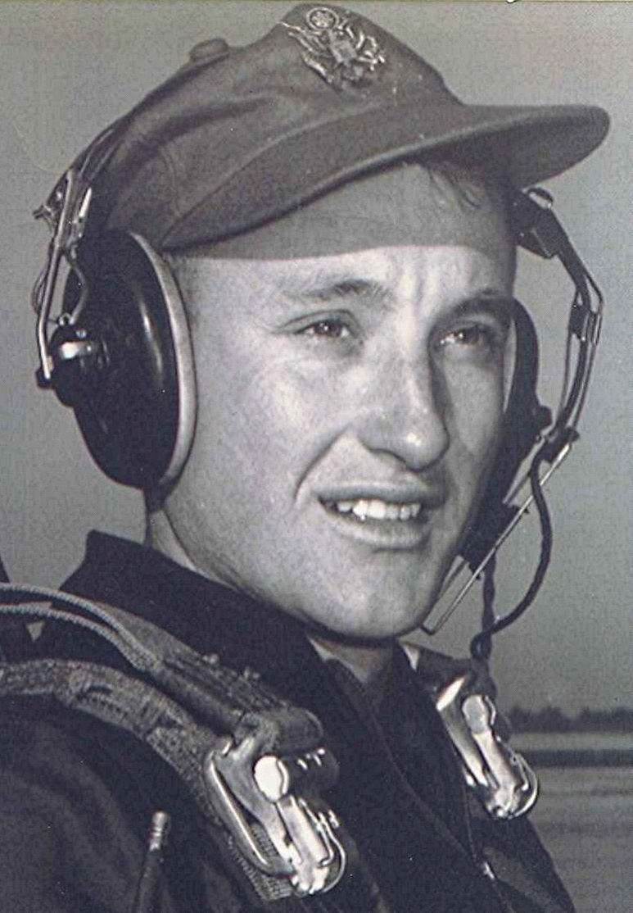
Thoughts at the closing of day
A Trip Back to the Place of my Youth
13 July 1999
Monday
Took another of those sad journeys yesterday to attend the funeral of my cousin, Charles Dean Sorrells. That 200 mile drive to Holly Springs provides lots of time to think of my years back there and the people who were a part of my life while we were growing up. Some of my cousins I hardly knew but my Sorrells cousins were part of our extended family back in those days when our lives were mostly centered around home and neighbors and relatives who lived within walking distance. All that now history as the curtain closes on the life of one who was a playmate back then.
Immortality
Each generation shares a common history of events, culture, and time; ours now covering some six decades. All too soon, the sun will set on our generation and our (earthly) immortality sustained only through the memories of those who knew us and in a few lines chiseled in stone.
B.D., Amateur Philosopher
Dyer, Arkansas July 13, 1999
Hope
"Hope" is the thing with feather—
That perches in the soul—
And sings the tunes without the words—
And never stops—at all—
~ Emily Dickinson (1830–86), U.S. poet.
God's Blessings
Boyd
Trivia: In the late forties comic strip "Dick Tracy", what was the name of Gravel Gertie and B.O. Plenty's daughter? Winner gets an afternoon in Bearden, 2nd place gets an entire day.

