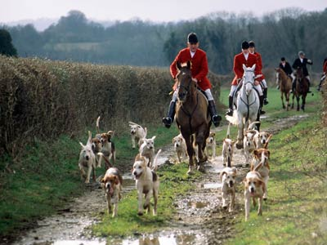
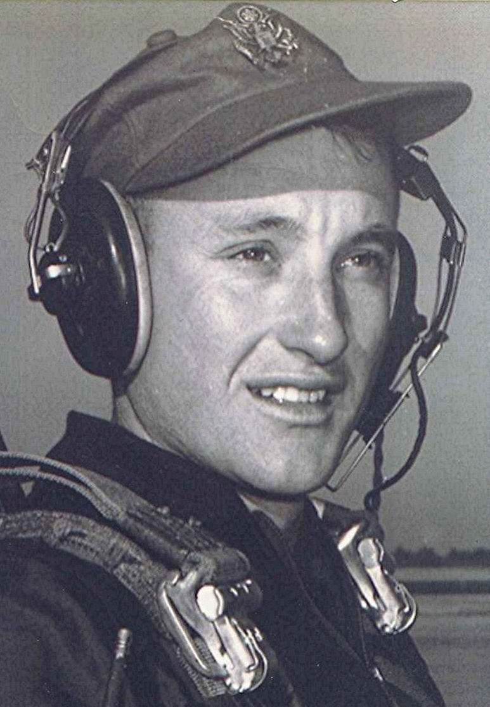
Thoughts at the closing of day
Nostalgia
13 July 1999
Got to discussing the old days with a neighbor the other night. And of the times back when there were no so-called “stock laws” and cattle roamed freely down the lanes and alongside the highways where the grass grew in abundance in rainy years. Just the other day I was thinking about the vast expenditure of time, money, and materials on keeping millions of lawns mowed. How did we ever live before all that rotary lawn mower business? When the only yard tool was a goose neck hoe which was used to scrape off the few bitter weeds that survived the chickens’ scratching and the drought.
There was another tool, the brush broom, used to sweep the dirt yards during the summer and leaves in the fall. We made ours out of dogwood branches, why dogwood I really haven’t a clue, except that it is a tough wood from which wedges were carved and used for felling timber. I still marvel at the sight of a small object like that lifting a giant red oak tree off its stump
But back to the cattle and open ranges where the cows and hogs foraged for themselves, recognizing no property lines except for the old worn out wire fences whose repair required unending attention on days too wet to plow. Neighbor told of the time when their pigs came home one night, happily grunting and squealing and staggering to the point of falling down. Further investigation revealed they had gotten into the mash of an overturned whiskey still in the hills near their home.
From that our conversation turned to the subject of fox hunting. Daddy was one of only about three fox hunters in our part of Dallas county. The others: one was the Methodist preacher, Brother West, and Pauline’s later-to-be father-in-law, Mr. George Pennington. As I have said in other places, “hunting” was a misnomer since the last thing they wanted to do was to catch the fox. All the excitement and entertainment, I gather, was in listening to the chase.
Brother West hauled his dogs around in the trunk of a 1941 Chevrolet sedan. I will never forget the sight of him piling dogs into the trunk until it was crammed full and their heads sticking out like objects in an overfilled garbage can. Without warning he would then slam the lid down, compressing dogs into something like half their normal sizes. Must have recreated a doggie version of The Black Hole of Calcutta in that small trunk. Far as I know they all survived. May have given them an additional incentive to run fast and breathe deeply, once they were out of that chest-crunching place.`
I may have looked forward to my first fox hunt with Daddy with some amount of excitement. I don’t remember that being the case but if it was, all that was dispelled after about an hour of standing around listening to dogs bark and Daddy’s hollerin’ to encourage them to stay after the fox. I do recall wondering like the Peggy Lee song , “Is That all There is?”

Hunting
One knows so well the popular idea of health. The English country gentleman galloping after a fox—the unspeakable in full pursuit of the uneatable.
Oscar Wilde (1854–1900)

