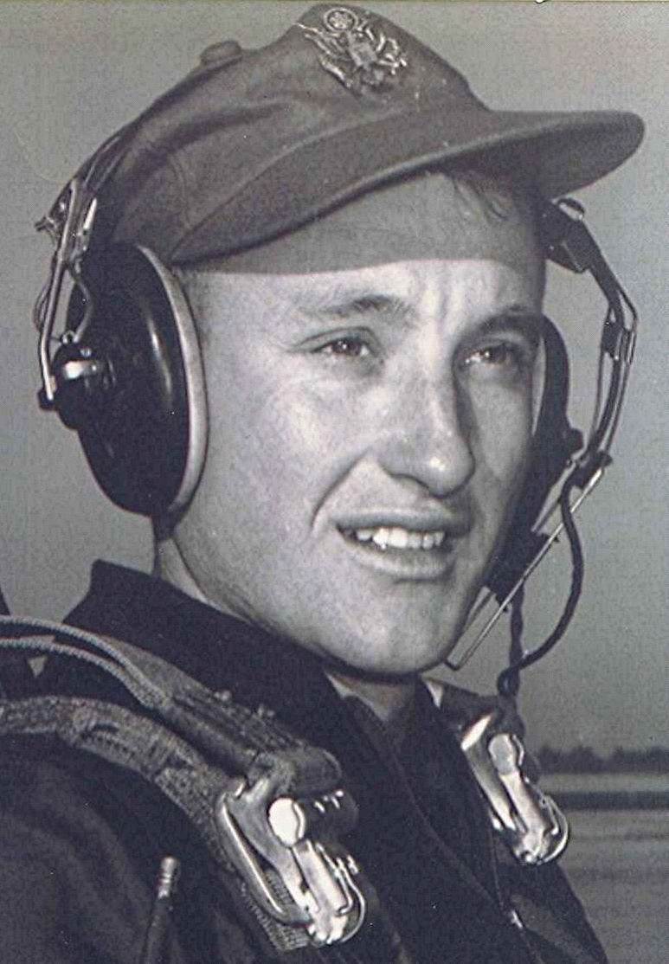
Thoughts at the closing of day
Jimmie Davis Redux
13 July 1999
Must have been ESP that caused me to comment on Jimmie Davis a few weeks back. The July 5, 1999, edition of The Southwest Times-Record had an Associated Press article, some of which is below:
BATON ROUGE, La. (AP)—The 20th Century hasn’t been all sunshine for Jimmie Davis, but as the singer, songwriter, and former segregationist governor approaches his 100th birthday, sunshine is what he’s best known for.
After a lifetime of hit tunes, movies, and politics, the simple song “You Are My Sunshine” is Davis’ best-known legacy. “There are worse things to leave behind,” says Davis, due to celebrate his 100th birthday September 11. “I’m glad to claim it as mine.”
Almost 60 years since Davis first recorded the song, people send it to him in music boxes; he hears it on answering machines and can find it in more than 300 versions and 50 languages. “Along with Happy Birthday, it’s the most valuable music copyright ever,” says Kevin Fontenot, a doctoral candidate at Tulane University, who is writing a book about Davis.

