
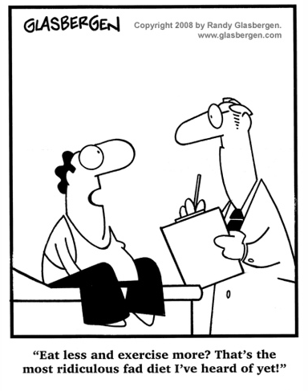
While in the Clutches of Senility
24 Aug 1998
Got a letter from Don Mann a few days ago. He, too, talked about the number of fellows that have had medical problems. He mentioned that in addition to himself, Billy Joe and Alfred, Robert Lee also had heart problems sometime back. Simple math tells us those numbers are approaching fifty percent of the surviving boys in the class.
Little wonder then, that some of us scurry around, seeking better eating habits. Lord knows, there are enough diets out there to go around; and I probably have tried at least half of them. Most popular, I suspect, are the low-fat diets which the food industry has latched onto as a good money maker. Practically everything imaginable has a low-fat version nowadays, including ice cream. We engaged in that drill for a long time, with some semi-satisfactory results.
One nice thing about the low-fat diet is that it very easy to tell if you are in violation of the guidelines. If something tastes good and has lots of flavor that makes the taste buds set up and take notice: you are eating from the forbidden list. On the other hand, if it is bland but bulky, maybe even tasteless, you can proceed on the assumption that it is probably O.K. for your diet.
While following this regimen, our eyes became accustomed to searching the food labels, scanning the list for the fat-gram content—four grams or less for a serving being desirable. Meanwhile, never bothered to check the carbohydrates (sugar) content, which could well have been off the map, and often were.
Next comes the high protein, low carbohydrate diet. A complete about face with the previous one. Now the eyes race down the food label to find the grams of carbohydrates per serving. Try not to look back up the list to the fat-grams which often are off the peg. Another advantage of this diet is that once you step inside the grocery store, about ninety percent of the stuff on the shelves is ruled off limits, In fact, all the things on your eligibility list could probably be stacked behind the customer service counter and room left over for old sales price signs and forgotten raincoats. However, it really simplifies shopping—no fruit, very few vegetables, and no snacks, sweets, cereals, etc, ad nauseam. One major problem here: the approved list is mostly meat and chicken. Both of which are not your everyday low cost items.
I guess the worst thing is the realization of having come to this point; where one's day is involved in following the rules laid down by some quack that has gotten rich off writing books about our human inclination to be gluttons. Which—and don't ask me how—reminds me of one of the numerous jokes making the rounds about the things that now have priority in our lives. Like planning our route so there is a comfort station (or at a minimum, roadside bushes) no farther apart than thirty minutes—some days I wish closer than that, especially after that second cup of coffee. But I discovered long ago, and at a much earlier age, the dangers imposed by traveling in west Texas where seldom is heard a discouraging word nor is seen a rest stop or even sage brush hedge.
~ ~ ~ ~ ~
Note: those wishing to un-subscribe to this newsletter may do so by sending five dollars in a plain vanilla envelope to I.M. Squatley, at the aforementioned address.
Published at infrequent intervals as events warrant and sometimes when they don’t.

