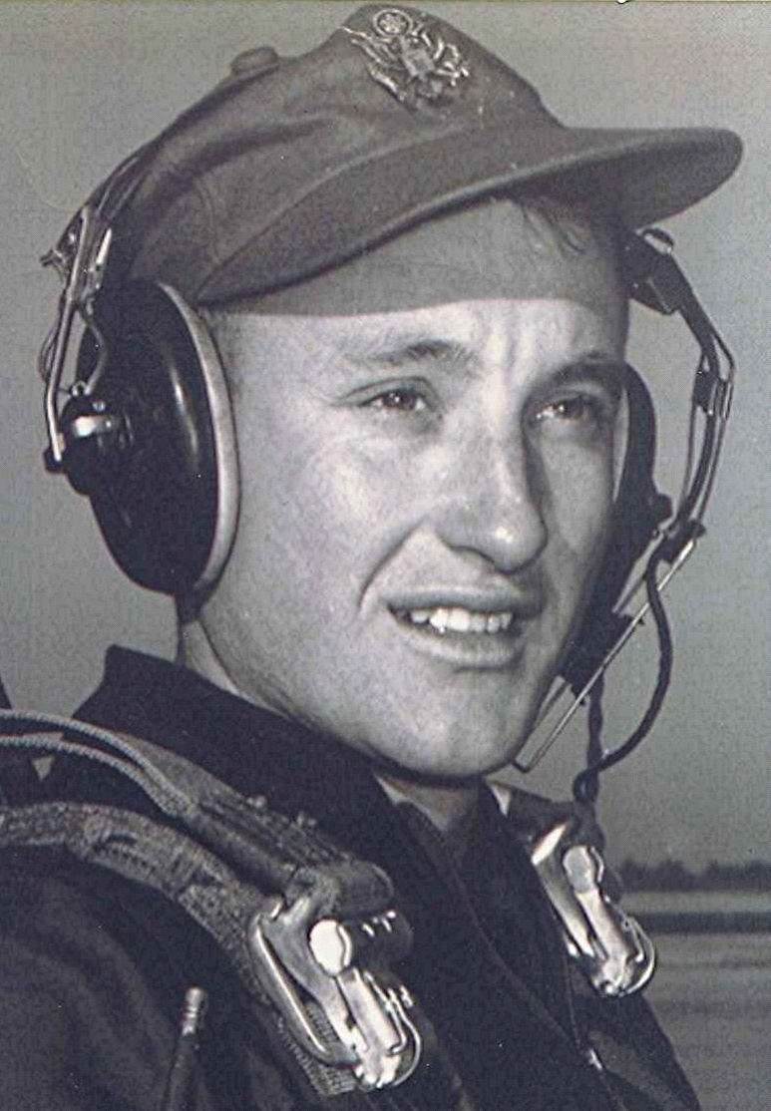
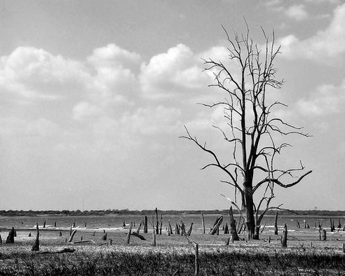
From the Back Porch
24 Aug 1998
The trees, sacrificing their leaves in an attempt to survive the prolonged drought, bring an aura of early fall. Helps to go along with that illusion, since whatever relief may come our way is way beyond our ability to influence, one way or the other.
I guess it has been my misfortune throughout my life, to have been associated with occupations or careers that are closely related and affected by weather. Now farming, particularly the dry land kind that we did back in Dallas County [Arkansas] in the late forties and early fifties, is about as weather sensitive an occupation that one can think of.
Even as a kid, I was acutely aware of the dangers posed to our livelihood by extended droughts or, for that matter, excessively wet seasons. Now if that weren't enough, I would then find myself in a career that is almost as involved with weather and it's impending hazards as was farming.
Aviation and weather are intimately entwined; not because of drought and floods, but another particular set of dangers, involving flying into conditions that are life threatening to those aloft in a thin metal tube traveling at hundreds of miles an hour. Or struggling to find a rain swept runway while in the teeth of a typhoon, with insufficient fuel to go any place else. With winds so fierce that the airplane couldn't be taxied, once it was on the ground.
Would seem that compared to those, worrying about dried up watermelon patches and shriveling perennials would seem almost insignificant. Ought to be, I guess, but it doesn't work quite that way. What got me started on this was a conversation with the teen aged sacker at our local IGA Grocery and Social Center. As he sacked our groceries the invariable subject of the heat and drought came up. Curiously, this young man was concerned that it might actually rain. When I questioned him about that, he expressed the hope that it wouldn't rain because he had football practice and that would make the humidity bad! When I reminded him that we needed rain badly, he stated that they had irrigation for their football field. End of problem, in this youth's mind.
That got me to thinking about the differences in the attitude of kids in their mid to late teens nowadays as compared to my own thoughts and concerns when I was that age. Seems to me that the me-first, to heck with everybody else, attitude has become an established part of our culture. And thus my thoughts travel in a circle, back to where I started, above.

