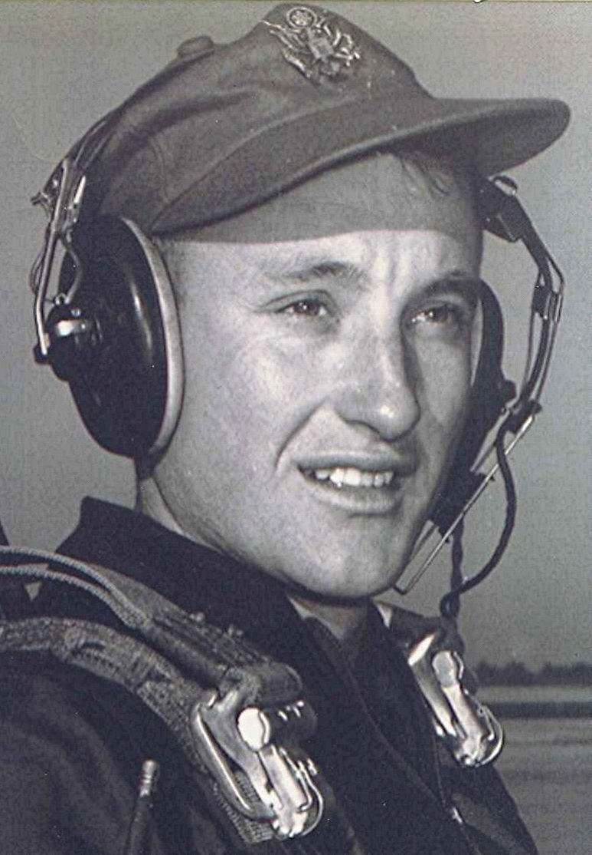
From the Front Porch
15 Aug 1998
We spend a lot of time visiting in a nursing home where my mother-in-law resides. All around us are those whose life is nearing an end, although one resident spent twenty-six years there. But most are basically marking time till the grim reaper makes his call. Gives me a different perspective about a lot of things; being there week after week among those who, in many cases, are in the miasma of some other world, their work in this one effectively finished. Sometimes the mind serves up its own anesthesia.
Additionally, it has brought me to the realization that throughout our lives we live on different islands, separated by age, interests, and other factors that make us unaware of what the occupants of other islands are experiencing in their lives. We see them from our own shoreline, aware that they are there somewhere, but beyond that, we live our own lives.
For example, when we attended school at Holly Springs the two teachers were probably in their late twenties maybe early thirties. Behind their backs we referred to them as "old maids."
Looking back at that from another time, today I realize those two teachers, rather than being "old" were in point of fact, quite young. All of which points up the disconnect between the young and their elders.
Guess I shouldn't be too critical when I get shoved out of the way by some youngster in a crowd, intent on elbowing his way through to whatever it is that he is after. There may have been a time in my life when I was as unaware of older folks and their sometimes infirmities. However, I do think they were shown more respect than I see now, maybe not.
As I reach the age my parents were during their last years of life, I have a much greater appreciation of their problems and infirmities than I ever did back then when I was a teenager with a totally different set of interests. Trouble is, it is now too late for me to tell them that I understand.
But such is the story of humanity, I suppose. We only have one go at life and often the lessons learned are too late to do much besides causing huge regrets and sometimes a great amount of guilt.
Strange how one episode, or one conversation, can make such an impression that it remains with us the rest of our life. Compare that to the amount of effort we, on the other hand, may spend memorizing or learning something that continues to elude us or to disappear from our minds after a few hours or a few days. Why is that? I believe that a lot depends upon the emotions attached to these events. Whether that emotion is brought to bear on the subject or whether the thing remembered provides its own.
I once saw a program put on by Steve Allen and his wife Jane Meadows. In it Mr. Alien would have guests who played the role of various famous people from history. These guests would sit around a table and visit, even though their historical characters' lives may have been separated in time by hundreds, perhaps thousands of years. What a concept. It made for some very interesting conversations, most of which I have forgotten, unfortunately.
However, one episode I remember clearly, although it may have been some thirty years ago that I saw it. Jane Meadows played the role of Elizabeth Barrett Browning, whose father resented her marrying Robert Browning. In fact, he disowned her and, when she and Robert moved from England to another country on the continent, he never attempted to contact her. Jane Meadows tearfully related how she (Elizabeth) wrote her father regularly all those years that they were away. When word came of her father's death, Elizabeth returned to England.
As she was going through his things after the funeral, she came across all the letters she had written him, tied in a package and unopened. I will never forget the powerful way that the dramatic actress portrayed the heartbroken daughter relating this terrible moment of discovery to the other guests from history.
~ ~ ~ ~ ~
While reviewing an old, old complete works of Elizabeth Barrett Browning's poems, I came across this dedication on the flyleaf:
Dedication
To My Father
When your eyes fall upon this page of dedication, and you start to see to whom it is inscribed, your first thought will be of the time far off when I was a child and wrote verses, and when I dedicated them to you who were my public and my critic. Of all that such a recollection implies of saddest and sweetest to both of us, it would become neither of us to speak before the world: nor would it be possible for us to speak of it to one another, with voices that did not falter. Enough, that what is in my heart when I write thus, will be fully known to yours.
And my desire is that you who are a witness how if this art of poetry had been a less earnest object to me, it must have fallen from exhausted hands before this day,—that you, who have shared with me in things bitter and sweet, softening or enhancing them every day—that you, who hold with me over all sense of loss and transiency, one hope by one Name,—may accept the inscription of these volumes, the exponents of a few years of an existence which has been sustained and comforted by you as well as given. Somewhat more faint-hearted than I used to be, it is my fancy thus to seem to return to a visible personal dependence on you, as if indeed I were a child again; to conjure your beloved image between myself and the public, so as to be sure of one smile,—and to satisfy my heart while I sanctify my ambitions, by associating with the great pursuit of my life, its tenderest and holiest affections.
Your
E.B.B.

