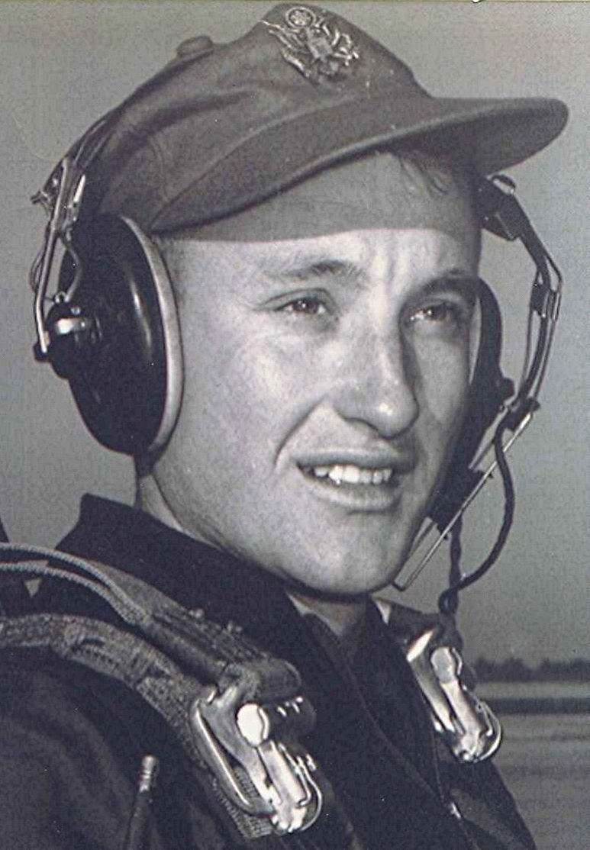
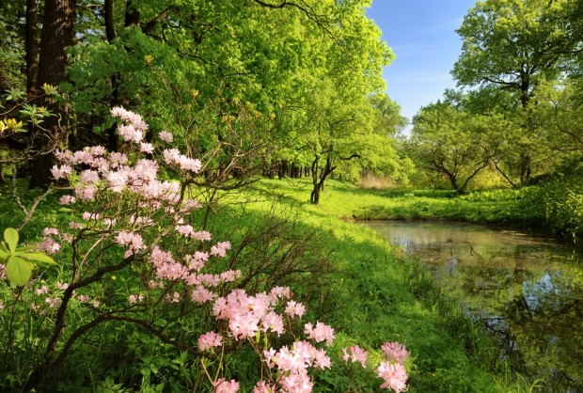
East of Eden
15 Aug 1998
The thought of fall not being very far away brings awakenings in the mind. The promise of cool nights and warm days stirs up old memories from the pages of the book of yesteryear. Those who are bored by repetitious wanderings probably ought to bail out now before this boat gets too far away from the dock.
The thought occurred to me recently that it would be nice to write about each, or if that isn't possible, at least some of my class mates and the impressions I still carry around from our association back then. Fortunately, when we look back across the valley of our past to the "purple mountains in the distance" we see those days through filters of memory that see mostly the good times.
At our next meeting, it would be nice if we reserve a few minutes to stop and think about some of our friends from back then--especially those whom we haven't seen for a long time. I am sure that each of us would have some special recollection or account that would refresh our memories Maybe provide us with information as to where they are or what they are doing. Matter of fact, we don't really need to wait until then to remember them; I guess there is seldom a day that goes by without my thinking of at least one of the bunch. Maybe I am just getting old and eccentric in that regard.
One thing about us in those days was that we were just average kids but on the other hand, a very exceptional group. Average in that there wasn't anyone who was extraordinarily smart--James Edward Shirron's intellect notwithstanding. But on the other hand, I believed then--and I think that time has born me out that we were an exceptionally good bunch of kids.
Good in the sense that we were basically honest, thoughtful, and considerate of not only our friends but others as well. And with a minimum of vices. Sure, there were the cigarettes we rolled and smoked out by the road and even the occasional sip from the can of beer when we thought we were impressing someone. Who that someone was, still rather uncertain. But all in all, such collective innocence would seem quite out of the ordinary nowadays
I am still impressed in this regard, when we get together these many years later, at how little that has changed Just a bunch of "squares" I guess the vernacular descriptive would be back then and maybe even now. As for me, I am proud to have been a square amongst a bunch of other squares.

