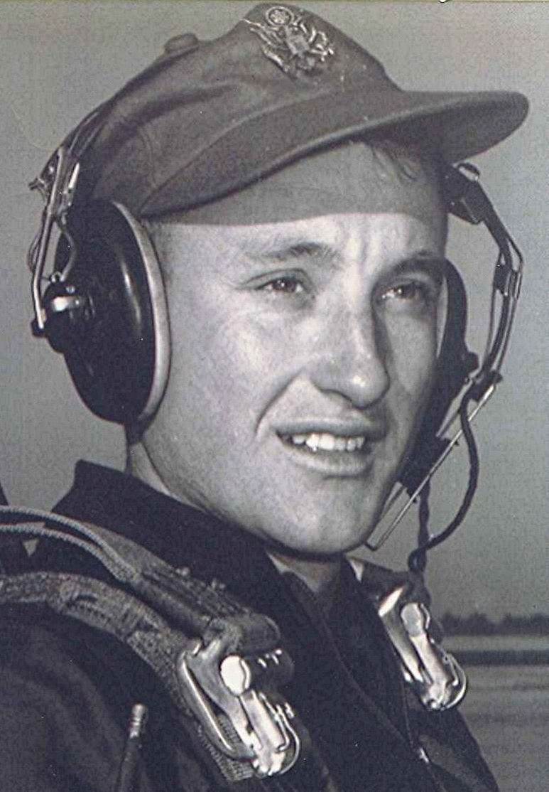
Present Concerns
26 Apr 1998

One wonders if it doesn't happen to the most of us; at this stage of life, wondering about the alternative paths we might have taken and wondering on certain days what the outcome might have been. Personally, the realization that my life's story is moving toward the final curtain and yet not certain as how it really came to this point, keeps me thinking about the early times. And that invariably brings back memories of Dallas County, Arkansas. It is said that the first animate object a baby duck sees after emerging from its egg becomes "imprinted" and the duck will regard that animal (or person) as his or her parent for the remainder of its "duck life." In a way, I have come to the conclusion that a phenomenon something on the order of "place imprinting" occurred when I was very young and forever since, I have felt the influence and pull of that special place in Arkansas.
In one of his books Christian apologist and author C.S. Lewis documents a dialogue with a friend concerning our memories and our past and how we feel about things that happened during our childhood. In it he mentions the English poet Wordsworth. Wordsworth, according to Lewis' friend, "believed that if he could have got back to certain spots in his own past, he would find there the moment of joy waiting for him." *
His idea (Wordsworth's) comes closest to providing me a satisfactory explanation of my own need to think and write about things from the place of my childhood. It began in the thirties when the South was in desperate straits, having experienced its own depression for several years before the rest of the country felt that same convergence of poverty, misery, and deprivation. What effect growing up under those conditions had upon my life didn't become apparent until I reached the age where I look back to those times, hoping to understand why I think and feel the way I do. This collection of short essays, newsletters to high school classmates, and other commentary is the result of some of those thoughts and recollections.
Boyd Dodson
Dyer, Arkansas
April 26, 1998

What though the radiance which was once so bright
Be now for ever taken from my sight,
Though nothing can bring back the hour
Of splendour in the grass, of glory in the flower;
We will grieve not, rather find
Strength in what remains behind.
~ William Wordsworth (1770-1850), English poet.
Intimations of Immortality.

* The Columbia Dictionary of Quotations is licensed from Present Concerns,
C.S. Lewis; "Talking about Bicycles" Page 7

