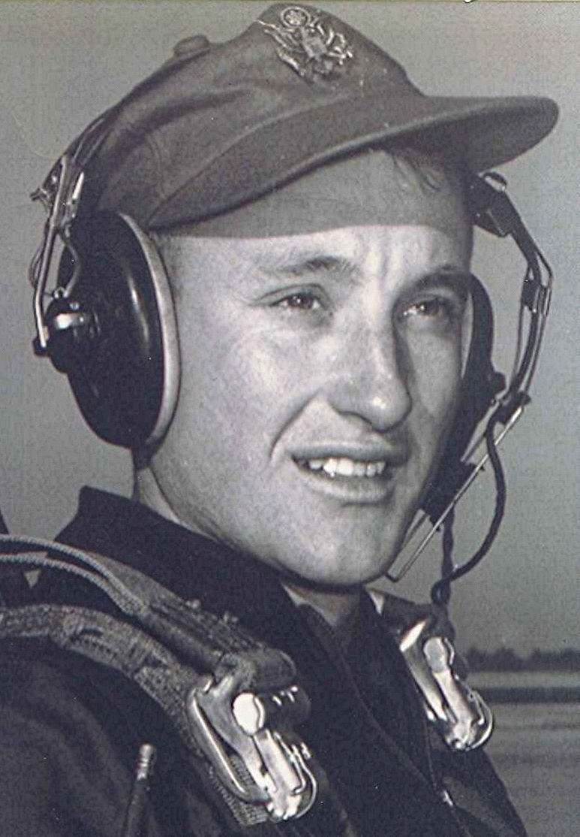
Who Are These People?
Spring 1998

The Student Council for school year 1950-1951 appears confident that they are up to whatever tasks they might be given. Thinking back, I can't recall any function that this particular Student Council performed; other than this one meeting for the purpose of taking a photograph.
Anyone agree/disagree with that? And where did they get those loud shirts? This group contained two future military pilots and several potential Miss America candidates.

