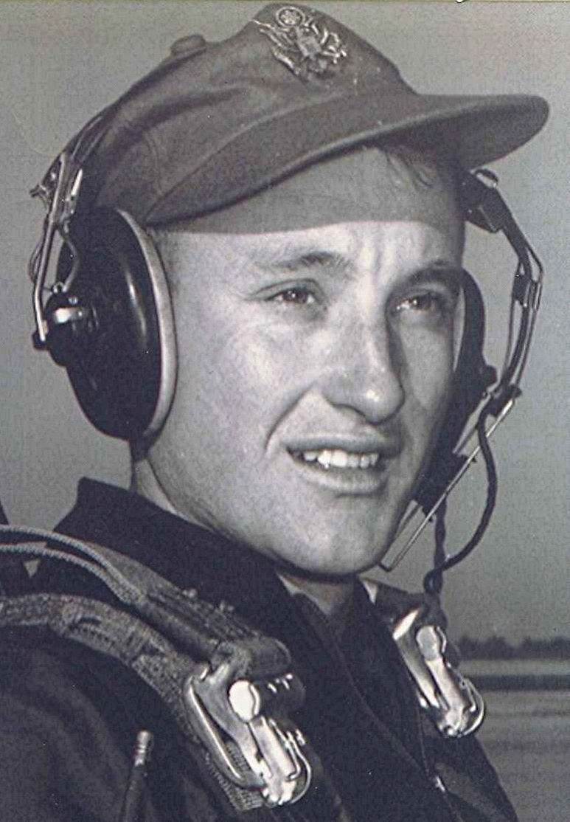
State Facility is Site of Reunion
Spring 1998

Refugees from the Sparkman School System (circa 1951) meet near Arkadelphia. To avoid the cost of renting a site, the group gathered at a combination Tourist Information and Rest Stop on the interstate. The afternoon was spent discussing past experiences and
counting the number of cars with out-of-state tags that stopped at the facility. Demonstrating that time had not dimmed their youthful optimism, they agreed to meet
again at the same place the next year. Bring a sack lunch.

