
Nostalgia
January 1998
"A feeling of sadness and longing
That is not akin to pain,
And resembles sorrow only
As the mist resembles the rain.”

~ Henry Wadsworth Longfellow (1807-82), U.S. poet: The Day Is Done, st. 3

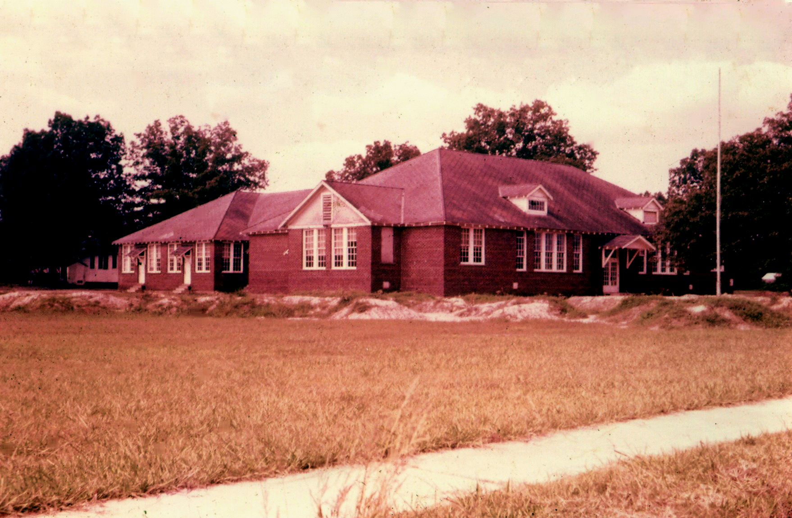

Sparkman High School, Sparkman, Dallas County, Arkansas, USA
1950s

