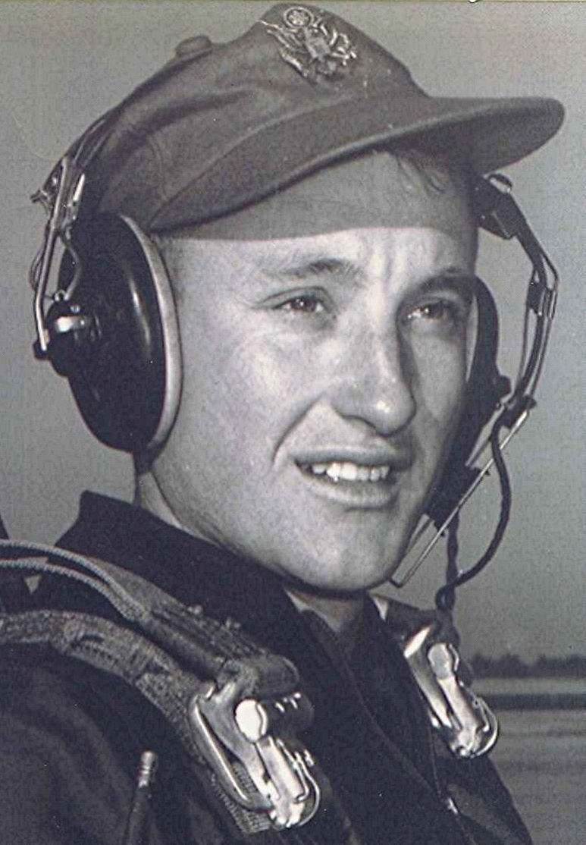
Melancholia
26 December 1997
A relative whose husband died almost a year ago commented recently that, regrettably, she only wanted to see Christmas over and done. This time of year for her has two sides; one is of hope and joy; the other of sadness and loss and facing the future alone.
*****
Melancholy is at the bottom of everything, just as at the end of all rivers is the sea. Can it be otherwise in a world where nothing lasts, where all that we have loved or shall love must die? Is death, then, the secret of life? The gloom of an eternal mourning enwraps, more or less closely, every serious and thoughtful soul, as night enwraps the universe.
~ Henri-Frederic Amiel (1821-81), Swiss philosopher, poet
*****
Note: Sorry about the small print above [Editor's note: not applicable in this document]. Needed to save space. However, if you can read it, you are cleared to drive at night.
Regards, Boyd

