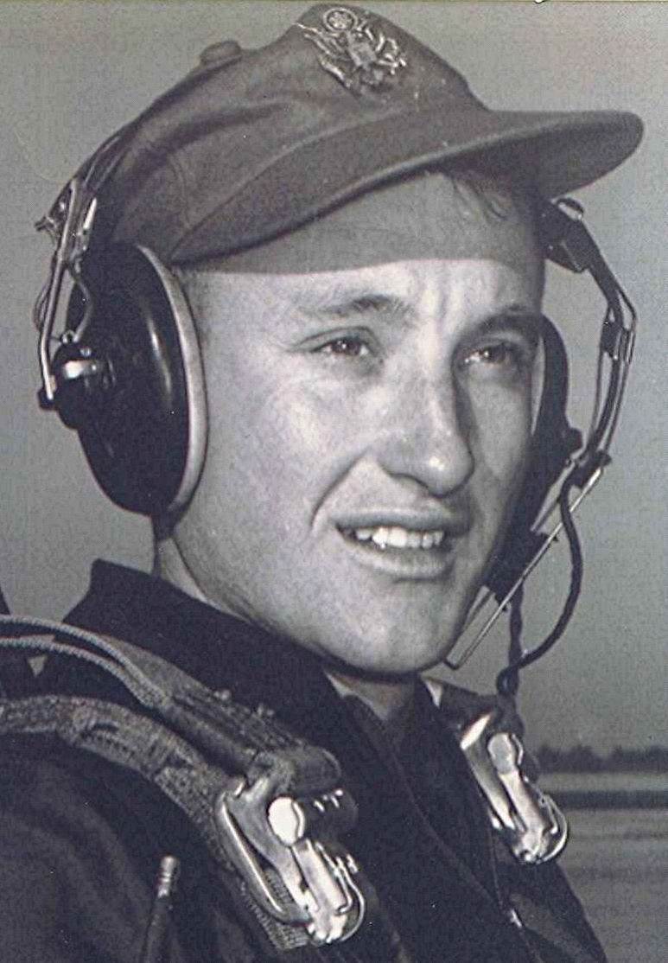
Return to sender
26 December 1997
Thought I would try to contact some of the bunch that I haven't seen in a long time. Some have moved someplace else, or the information I have is not current. Does anyone have Vada Sims Cox's address? Her mail came back; the time-limit for forwarding expired
Got a card and a note from Fred Randle. Expressed the wish that he were closer, so that we could share in the stories and the reminiscing. I bet Fred could contribute significantly to our library of twice-told stories. Think of all the treasure that we could share if some of those who have been away for so long could join us. Hope springs eternal, but don't wait too long!.
One of our former classmates, Pearlene Stiles Yeager, lives south of Malvern in the same community as my sister. She requested eight of my Holly Springs books¹ to distribute among family members. Always glad to hear that someone enjoys reading about the old days in Dallas County. My purpose in putting my thoughts on paper was that it would revive others' memories of those depression and post-depression times and maybe provide a small window to the past for those who weren't around back then.
[Malvern, Hot Spring County, Arkansas, USA]
1 ~ [Editor’s note: Where Violets Bloom, a collection of the writings of Richard Boyd Dodson.]

