
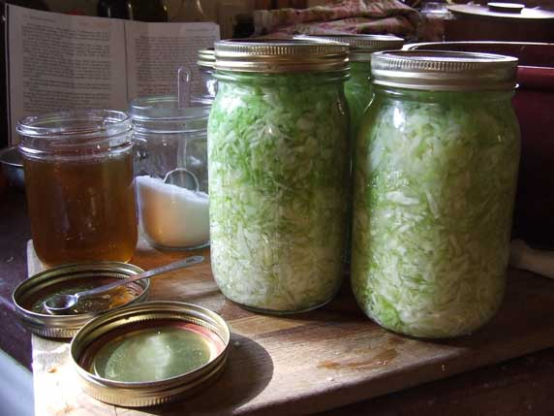
From the Deutschland
(of inherited genes and related tastes)
September 1997
My daughter says it is due to our German ancestry. Could be, as I found some of the same things served back home when, years later, I was in Germany. They served a vinegar flavored potato salad that was close to the same thing that Mama made. Back then, anything sour went well. Sour pickles, the aforementioned potato salad and probably best of all, there was home built kraut. Being part German, I like German style: exceptionally heavy, with tons of fat and carbohydrates. Mostly in the form of meat and potatoes fixed various ways; boiled, fried or whatever. Back then, in Holly Springs, we didn't know about Bratwurst and Sauerbraten. Too much removed by distance and time from the meat markets at Mannheim, or Stuttgart, or from wherever my great grandfather emigrated. But Mama knew how to cook spare ribs and pork sausage and other parts too indelicate to describe here. Scrapple. Isn't that German? I think it is, at least they love it in Pennsylvania. Then there was Souse laced with vinegar to give it that delicious just-the-right-amount of pungency. I am getting hungry just remembering all that stuff.
But I stray off my intent to describe the art of making kraut: We'd haul the cabbage to the back porch in number three wash tubs where it was close to the well and a generous supply of water. After trimming and peeling and washing, the heads were chopped with kraut cutters, whose description is too involved to go into. Then a five gallon or larger churn and a goodly amount of salt was placed near the cabbage. The chopped cabbage went into the churn in layers and pounded with a wooden potato masher or club to produce juice for the brine. Salt added generously, each layer pounded some more. Soon, near the top, the brine came up over the pounded cabbage and nearly spilled over.
A churn lid wrapped in a clean sheet and weighted with a brick kept the fermenting cabbage in place. All this was set inside the smoke house for a couple of weeks to ferment and ripen. I couldn't wait for the kraut to be ready. I sneaked into the smoke house, lifted the lid and scooped up a handful of the stuff from time to time. Don't know if Mama ever missed it or suspected I was snitching it; if so she never said anything. After the remaining kraut fermented and bubbled for maybe two weeks, it was canned in quart or half gallon glass jars.
The stuff that charades [parades?] as kraut on the grocer's shelves is a far stretch from what we used to make, but I guess it will have to do.
[Holly Springs, Dallas County, Arkansas, USA]

