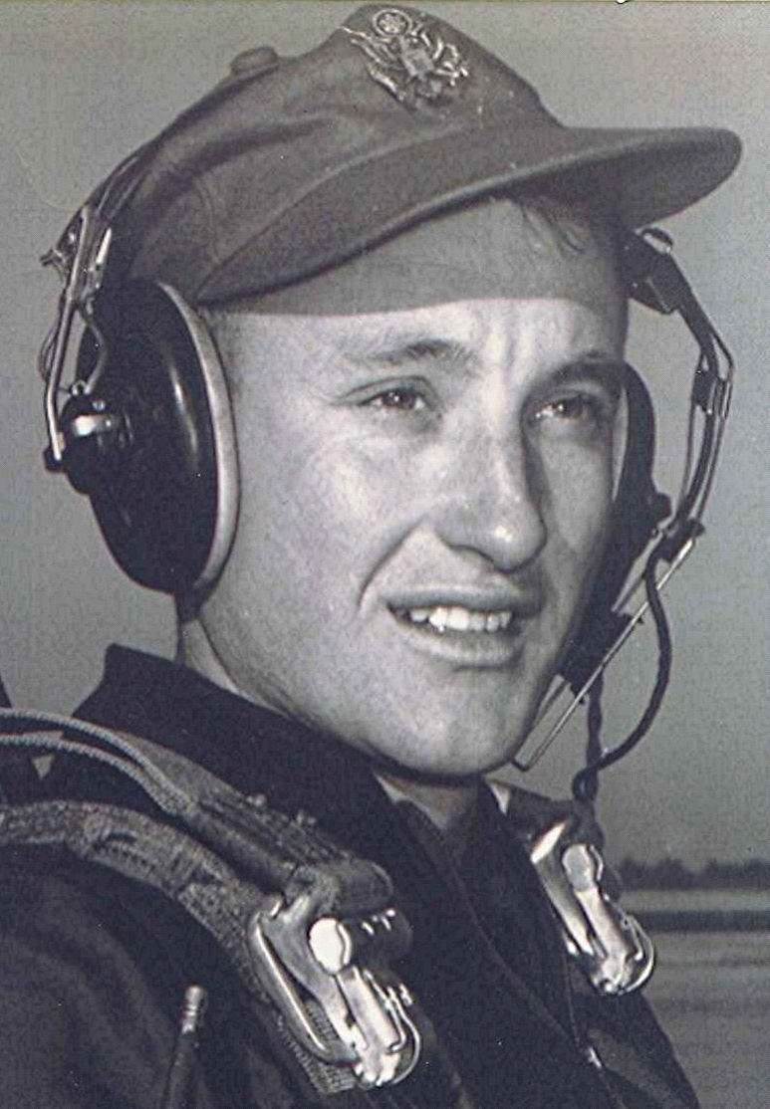
Autumn
September 1996

The air turns cool in the evenings. There is a hint of the coming of fall and soon we will hear the geese flying south. The summer is over and done. So many things we planned with enthusiasm in the spring, when the earth was green and flowers blooming; such as our intentions to contact old friends and re-establish links with those who have gone down paths apart from ours.
Why, this desire to renew ties from an earlier time, when our youthful minds were filled with idealism; with hope and confidence of what lay ahead? Who knows why these thoughts fill our idle moments and quiet nights as some marker from the past reawakens our memories.

Boyd

