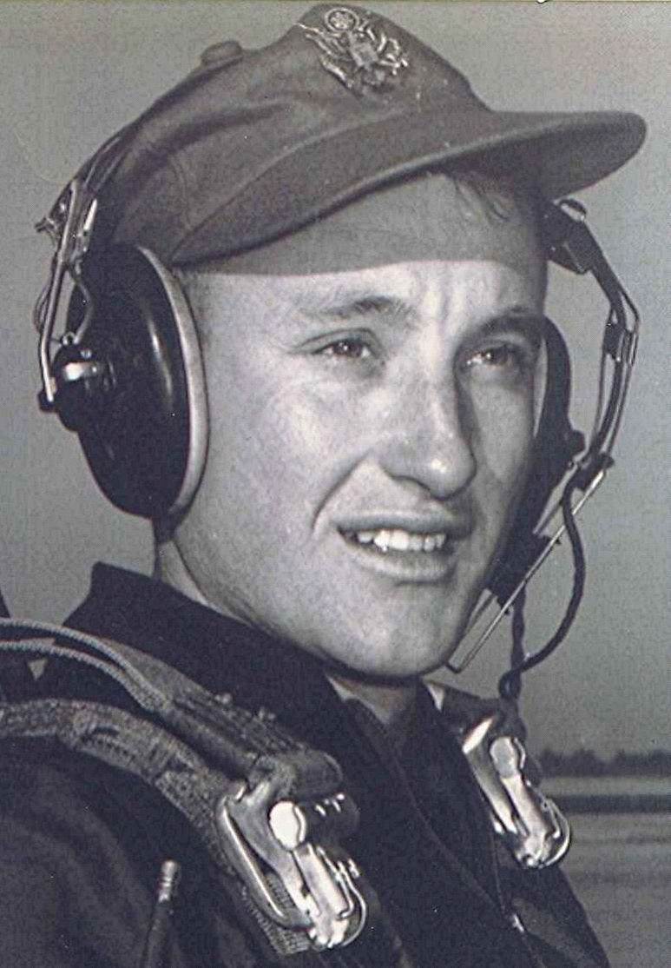
Upon Returning
September 1996
Pretty soon we will be loading the wagons and calling the dogs and heading out to south Arkansas and the piney hills; to Lake DeGray and the 45th class reunion. In south Arkansas on warm October afternoons, with a slight chill in the air as the sun sets, I can't help thinking (and hoping) that Heaven may be like that.
[DeGray Lake is a reservoir on the Caddo River, 8 miles from Arkadelphia, Arkansas, USA. ~ Editor's note]
There is something about being away for twenty five years. That is how long it was between leaving and coming back home. Such a separation, in spite of all its down sides, provides us with a different perspective. With that in mind, I am thinking mostly in reference to the high school friends from whom I was separated in quite an abrupt fashion upon graduation. We came together in that one place, we spent several good years together, then with that last bell we went separate ways. For me, the changes were great; not only from the standpoint of being out in the working world, but the whole new set of associates and acquaintances that accompanies taking such a different road in life.
Going off to college contains some of those elements, but not to the degree as leaving for another part of the country, even another part of the world and staying away for twenty some years. But such separation did allow us who were away for a long time to create in our hearts and minds an idealized vision of how things were back home.
You see, my Sparkman and Holly Springs never aged all those years, even though the people I may have seen during the brief visits back did—but only for a little while. For when we were gone again, the old vision crept back in.
I was reminded of this not too long ago when writing to someone from the old days at Sparkman. He lives there now and has done so most of his life—if I am right. He implicitly apologized for not seeing the need for restoring some of the few vestiges that remain from our time there at the high school, namely the sidewalks. I had written him on the subject of restoring them and the bits of history reflected in the names written in concrete.
Reading the letter he wrote made me realize that living there and seeing all the changes, gave him a better insight into what really is. Contrast that to my version of the way things ought to be based upon recollections of past things, and as I would have them be today. In a way, he brought me back to reality and needn't apologize for not having the same nostalgic inclinations (or illusions, take your choice) as some of us who have been away.
Nothing like living there all along to dispel some of the romantic notions I had about preserving the remnants of days gone by. A one-day visit accomplished some of that for me the last time we were there. But then I don't want to get off on another "Purple Mountains in the Distance" lecture about the value of memories as opposed to what really was or is.
The second part of being away so long is the effect it had upon past friendships. I should have known that, but now it is clear. The friend of 1951 is not the same friend twenty five years later or for that matter, forty-five years later. In many ways, our commonality ended back there. That probably explains the propensity we now have to talk mostly about those common things and times when we get together. But that's fine. Doing that helps us avoid the differences we now have because of the years apart.
Considering all that, one could then ask: "In that case, why even go to reunions?" I believe memories compel us to go; at least for me that's true. Memories not only make up a very important part of our lives, they help define who and what we are and were. To get some idea of the power that memory exerts on the mind, one only has to visit a nursing home. There we can see some who now live in a world apart from reality, residing in some obscure compartment of their mind somewhere way back in their past. They can speak logically of things that happened fifty, seventy, or even eighty years ago, but may be unable to recall what they had for breakfast—or even recognize us as to who we are. Old memories giving coherence when the rest of the mind is incoherent. Why that is, I doubt that even the medical community understands.
But memories are more than mere tools to get us through the day or to fill the voids in the minds of those suffering from Senile Dementia. They allow us to walk away from the confinement of the present to visit the past and all the ones we were with back then; our own time machine, not limited by space or time or events. I would suggest that in a way, this exercising of our memory allows us to appreciate how God exists beyond the limits of time and space that confine us mortals.
But back to the friends I mentioned before, those with whom I was close. In a romanticized way, I truly expected that we would meet again after all those years and take up where we left off. Something that most likely occurs only in novels or other products of the imagination. I was deeply disappointed when it didn't turn out that way at all. Then I realized that we have too long lived a world apart, crossed too many bridges and taken paths that probably won't ever converge again, except at occasions like reunions and funerals. That saddens me.

