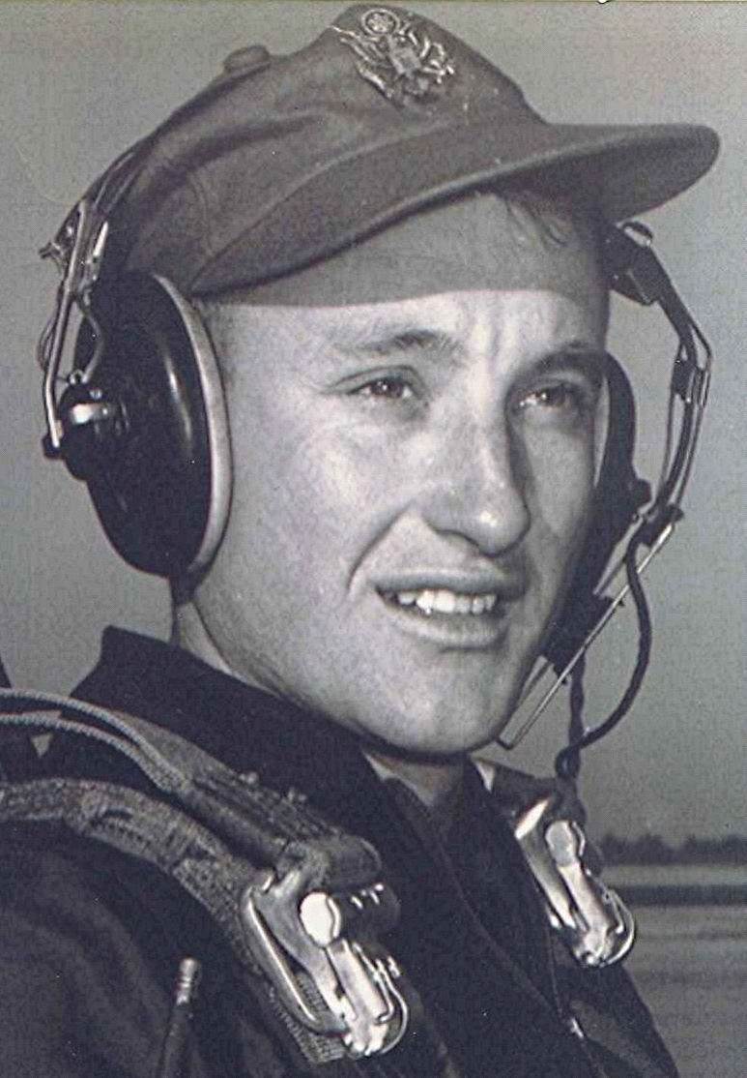
In Memory Of:
Duane
Irene
Ruby Faye
Our dearly beloved classmates who have preceded us in death; we cherish the memories of them back in the good times; their laughter; their love of life and above all, their friendship.
Boyd ~ Fall 1996
Crossing The Bar
Sunset and evening star
And one clear call for me
And may there be no moaning of the bar,
When I put out to sea,
But such a tide as moving seems asleep
Too full for sound and foam,
When that which drew from out the boundless deep
Turns again home.
Twilight and evening bell,
and after that the dark!
And may there be no sadness of farewell,
When I embark;
For tho' from out our bourne of Time and place
The flood may bear me far,
I hope to see my Pilot face to face
When I have crossed the bar.
~ Alfred Lord Tennyson ~

