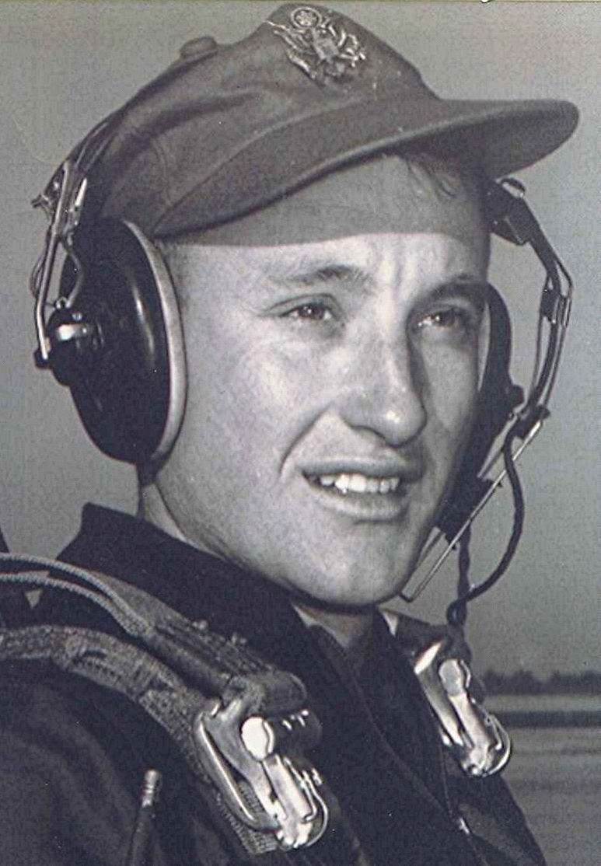
No chicken snake!
Vowing to not succumb to the proverbial siren call of wine, women, and song during that year in Vietnam (well, there was a bit of wine available at the Officer's Club, but no women and not much song), I decided to channel my energies into running every day ~ during which year, I lost close to seventy pounds.
Most of the roads on base were paved but some of the lesser-traveled ones were dirt or sand. One, in particular, led off through the old French farm and meandered around before rejoining the paved road some two or so miles farther on, near the dining hall. It was my favorite place to run, since the sand providing some protection from the jars and jolts that caused shin splints.
Moonlight in the jungle can be a beautiful and deceptively peaceful thing, and I took advantage of it whenever I could by running the road at night. I had been doing that for some months when one night, just as I started down the dirt road, above the sound of my feet pounding the earth, I heard the metallic clack of a rifle bolt being drawn. I skidded to a stop about the same time as someone yelled, "HALT!" from the dark shadows beside the road.
My heart leapt into my throat as I could envision the muzzle flash that would be leaping out at me from the darkness. Panic stricken, I threw up my hands. "Don't shoot! Don't shoot! I am an American!" The young sentry stepped out into the road and shined his flash light on my clothing, which consisted of running shorts and tennis shoes. "What are you doing out here?" " I'm running. I've been running on this road at night for months." "Well, you are not supposed to be out here," he snapped. "O.K., but nobody ever told me that." "Well, you're not supposed to be out here at night." "O.K., O.K.!"
It wasn't too long after that, it was afternoon on the same road just a few hundred yards down from where the sentry was that night. It was there that I saw the track. I remember snake tracks from back on the farm. A large snake's coils will wipe out a path perhaps three or four inches wide as it slithers along. This track was between a foot and sixteen inches wide where the Python or whatever, had crossed the road in the sand. I couldn't help but remember the huge snake in Robinson Crusoe that came out of the jungle and crushed the poor helpless burro in his coils.
I can only imagine what would have happened had I stumbled over that thing one of those nights when I was running down that road in the dark.

