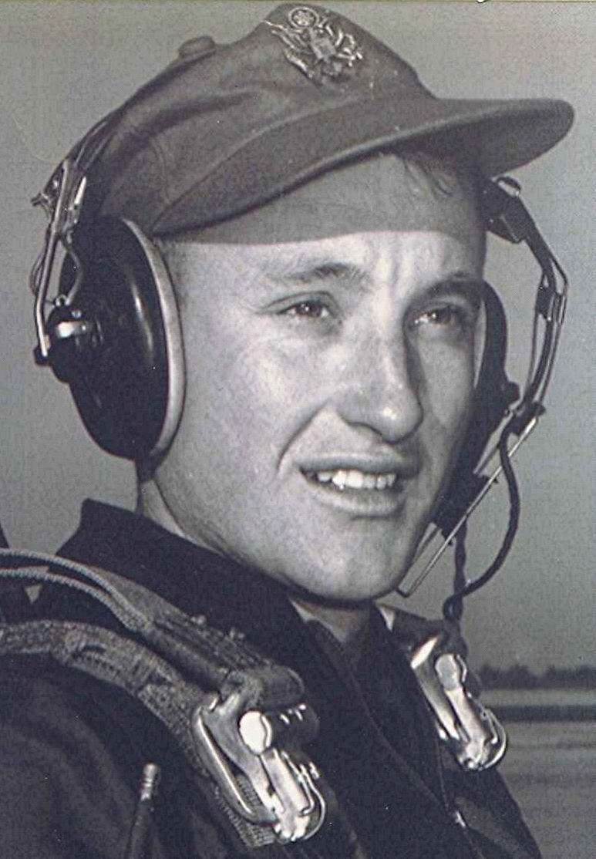
Jungle Cowboys
The way the livestock was treated was both inhumane and cruel. The cows and hogs would be boxed in crates and left for hours, maybe even days, waiting in the hot sun on the ramp for an airplane to carry them to their destination. Once I picked up a load of hogs that had been so long without food or water that they were half dead.
Another crew told of picking up a water buffalo that had been crated up and waiting on the flight line for more than a day. Needless to say, this fellow was vastly mad and out of sorts. They landed at their destination in the jungle where the local Vietnamese civilians were waiting to get their cow. The crewman responsible for loading and unloading the airplane reached up and took the crash ax off the wall. (in theory, this ax was to be used to chop your way out of the wreckage in case of a crash landing.). His intent was to knock some of the boards off the back of the crate so the animal could back out of the crate and be led away. Instead, when he swung the ax, it crashed through the boards and struck the poor water buffalo full force on the rump.
That was it, he had had enough! The crate exploded as the buffalo flew out and headed for the woods. At the edge of the clearing he stopped and looked back at his tormentors as the airplane sat there with both engines idling, the propellers slicing the air.
Suddenly, the irate bull decided to take on the airplane apparently considering it to be the enemy. He headed straight for it, head out, horns at a position of readiness. Fortunately for the buffalo and the airplane crew, he lunged past the spinning propellers. Had he gone through them it would have destroyed the bull as well as the airplane engines, and maybe even the airplane. Instead he gored the fuselage a few feet behind the trailing edge of the wing.
The aircrew reported that the last thing they saw as they hurriedly took off was a buffalo in full flight toward the jungle, behind him a bunch of Vietnamese frantically chasing their meat supply. As far as we know, our outfit had the only airplane in the Air Force to be gored by a water buffalo.

