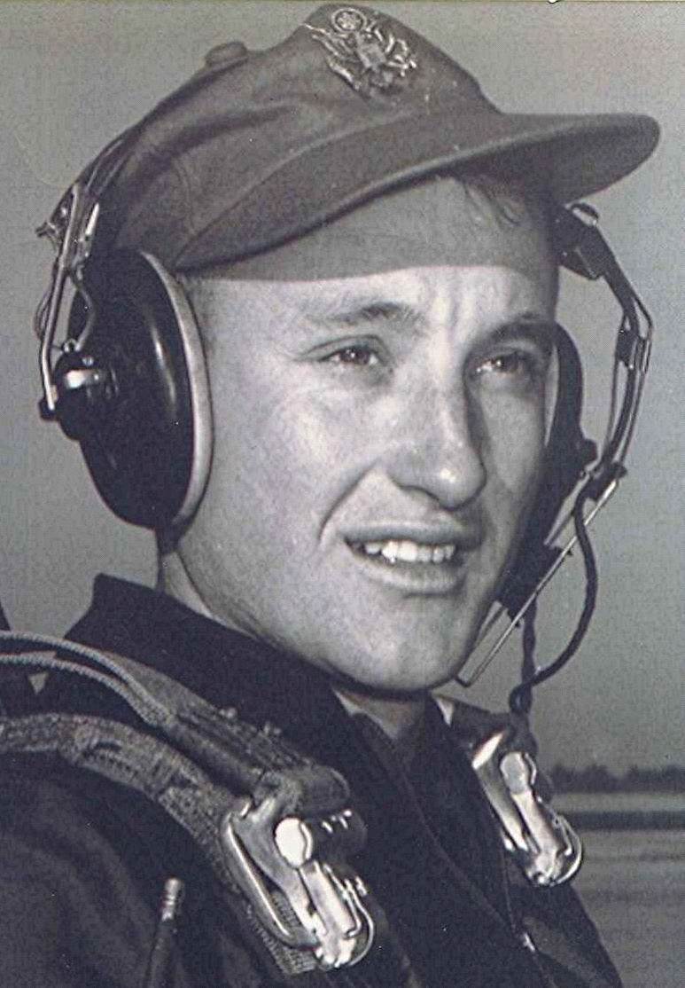
What did you do in the war, Daddy?
Phu Cat, Vietnam, was one of the best kept secrets of the war. Located on a hill a few miles inland from the small seacoast town of Qui Nhon, it had been built from scratch by the Red Horse Battalion of civil engineers. Built on the site of an old French farmstead, it spread out over several hundred acres.
When the twin-engine Caribou on which we two replacement pilots flew in from Saigon pulled up in front of the terminal, we could have been at a small town airport somewhere in the United States, except for the sand bags and metal revetments around the cargo and fighter airplanes parked on the tightly guarded flight line. I was taken to my quarters directly from the operations building as it was late in the evening when we arrived.
Having heard bad things about the food and housing in Vietnam, I was expecting the worst. To my surprise, the individual rooms assigned to pilots had an air conditioner and a refrigerator as well as a fairly comfortable bed. It was beneath these that I stored my helmet and flak jacket for use in case of a rocket attack—but that story and how I mistook a water pail for the helmet during an alert will have to wait until another day.
After a few weeks, I was getting acclimated to the routine of getting out of bed each morning well before daylight. Still groggy, we climbed aboard the pickup truck driven by the lieutenant duty officer that first took us to the chow hall for breakfast then to the ready room down at flight operations. The second pleasant surprise was the quality of the chow served in the mess halls. Our chow hall at Phu Cat won first place for combat kitchens the year before and second place that year.
Our Squadron was trained for short-field operations in the mountains. Yes, Vietnam has mountains and even snow falls there on rare occasions. The dirt landing strips were small patches cleared out of the jungle and scraped off to provide a thousand feet of dirt runway. Having flown off thirteen thousand foot concrete runways for years, it was quite an adjustment to being a bush pilot. We landed at places that were often were overgrown at either end with jungle trees and bamboo that reached up and slapped the bottom of our airplane if we were daring (we called it proficient) enough to flirt with the treetops when coming in.
Bamboo makes an extremely loud noise when it strikes the aluminum skin of the Caribou in flight We didn't talk much about that except in the bull sessions back at the barracks, as flying into treetops would have been frowned on by the folks in the headquarters at Saigon.
Playing tag with the tops of the trees off the end of the strips wasn't just an idle game. The desired spot to touch down the wheels was three to ten feet down from the end of the runway, the closer to three the better. That way, practically all of the thousand foot strip was left for stopping. Some of the most sporting places to land were on the runways that had been overlaid with pierced steel planking, a holdover from World War II. When the PSP runways were wet from rain or dew, they might as well have been covered with grease.
From our base at Phu Cat we launched each morning before dawn and flew to a large supply airport such as Da Nang on the coast, or Pleiku, in the central highlands. From there we fanned out in different directions, shuttling ammunition and supplies to the numerous fire bases and special forces camps throughout the northern part of the country. Our cargoes varied from supplies and Howitzer shells to live animals, ducks, chickens, pigs and even water buffalo from time to time.

