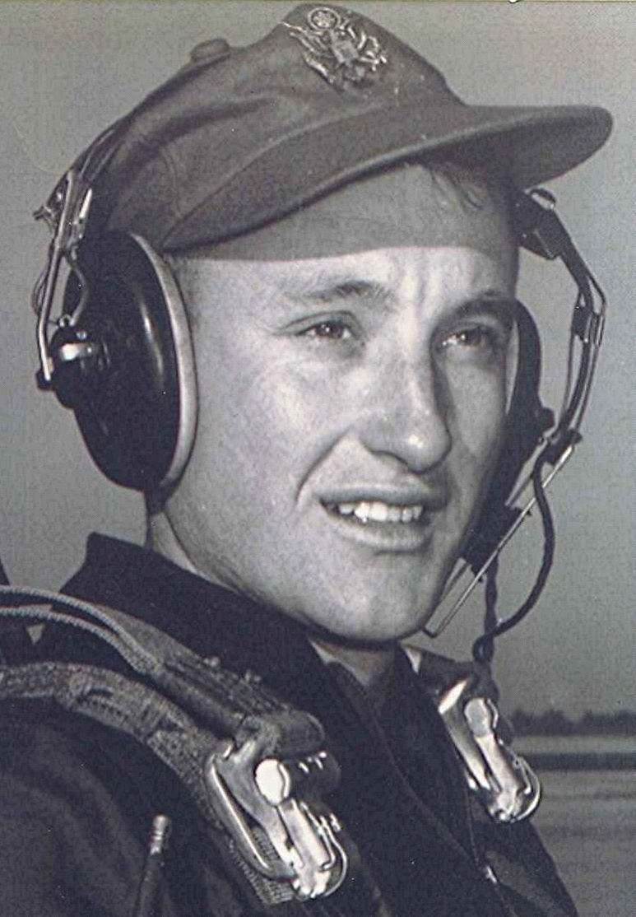
Salute to the common man
It is quite difficult for me to write or talk about some of the more profound things about life without mentioning my hero, the Christian writer, C.S. Lewis.
Having said that, I once again offer for your consideration an idea he proposed: It was that beyond time and eternity, the great and famous may not be nearly as important to God as the beggar on the street and others who don't amount to much in this world. What a comforting thought, especially in the midst of the political season, when the quest for power is most strident.
I believe God gives us, from time to time, an insight into what's important and what's not. I recall hoeing in the garden early that afternoon when my wife, obviously under great distress, came out the back door and called to me. She had just been notified of the death of our grandchild.
In an instant, all the daily things I had considered important just a few moments before were washed away with the awful news. Suddenly, the garden, the grocery bill; who is most powerful in the country; who is president or what happened in Washington or Little Rock that day didn't matter anymore. Grief can concentrate the mind on the basics and the absolutes of life in a way that nothing else can. Lewis describes pain (grief) as God's megaphone, getting our attention in ways otherwise not possible. The challenge, as I see it, is to have an understanding of the priorities in life, even in the good times.
In our house, we have seemingly endless discussions, even arguments about how the score will be evened. A commonly heard expression is, "just wait, they'll get their just dues." I know that thought may be comforting, but it won't necessarily stand up against all the evidence to the contrary. There have been countless instances where the, "just wait, they'll get what's coming" never happened while they were on this earth. I suppose in those cases, we can stand at the side of their grave (figuratively) and say, "well, they'll get their just dues for sure now." That may be a way we have of comforting ourselves in the face of all the injustices we see going unanswered in this world.
The thought then comes that we will never really know will we, whether or not they ever get their just dues. This incompleteness leaving us with an unsettling feeling over the great mystery of evil apparently triumphant and the unfinished business of balancing the scales. If anything is to make sense to us, that must somehow be done.
Back in antiquity, David was greatly troubled by the flourishing of the wicked. We continue David's lament as to why. The answer not yet revealed.

