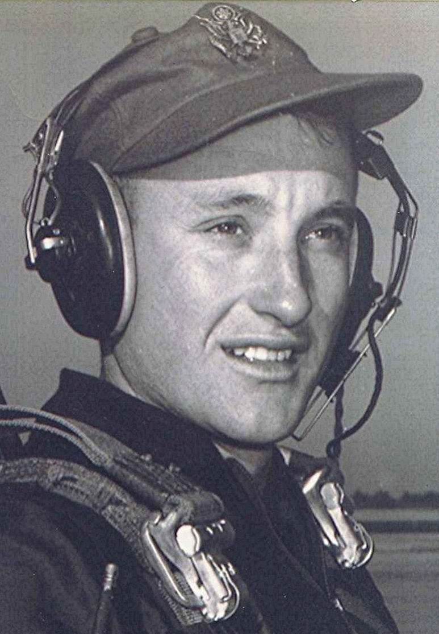
On contemplating Barbecue and other lost arts
A long time ago, Uncle Johnny Sorrells gave a yearly picnic he called a birthday dinner. The main feature of the dinner was the barbecue that he prepared. I don't know how many folks attended, but it seemed to be close to a thousand to a small boy like me.
Invitations were open to all. And folks from Holly Springs, Mount Carmel and Mount Olivet came, as well as some from Sparkman, Bearden and Fordyce. There would be several cars from distant points like Sheridan and maybe even Little Rock or Memphis. Mama would introduce me to first cousins that I had never seen before and probably wouldn't see again until another gathering like that.
She came from a big family, twelve or thirteen, counting some who died at a very early age. Several of my aunts and uncles had already died when I was born and she would introduce those surviving cousins as the child of Uncle so and so or Aunt thus and such. Meaningless names for an eight or ten year old, except that I recalled her talking about them from time to time.
But I get ahead of myself. The really interesting time for a kid my age was the day before, on a Saturday afternoon. That is when the large pit in the ground was made ready for the cooking. Fence wire was stretched across it and anchored with steel stakes. What held the wire up off the ground was a bordering frame of green oak saplings cut for that specific purpose. Green so they wouldn't catch fire from the heat of the coals in the bottom of the pit. Nearby, a fire burned the logs of hickory and oak that supplied the coals for the cooking. These were spread over the bottom of the pit, using a long-handled shovel.
Everything got going about the middle of the afternoon. A couple of pigs split down the middle into halves were placed on the wire, along with several goats, likewise split. The meat was well over a foot above the coals. That meant hours of cooking time before the heat reached the thick parts.
Come nightfall and the cooking continued. By this time the fat began dripping onto the live coals down below and the aroma that drifted up with the smoke was indescribably tantalizing. On through the night, way past our bedtime, but we kids wanted to stay up and listen to the stories the older folks were telling. As the night progressed the taller the tales. Finally we had to leave, but Uncle Johnny and a couple of others would stay there all night attending the cooking.
We returned on Sunday morning. By that time the cars were coming down the dusty lane and parking beneath the pines and under the oak trees. Folks from all over, greeting and laughing and talking about old times and old acquaintances. Then around eleven or so in the morning the meat was ready to be taken off the pit.
That's when Uncle Johnny brought out the ingredients to his famous barbecue sauce. Anyway, it was famous with everyone who had eaten his barbecue. Recent conversations with his children reveal that the recipe didn't survive his passing. He mixed the sauce in dishpans out there on the long plank tables that ran from tree to tree:
Vinegar by the gallon and butter by the pound and sugar and cans of red pepper and black pepper and some other ingredients for the pungent and spicy sauce that will forever remain a mystery. The cooked meat was cut into small chunks and these dumped into dishpans, washtubs and other containers, the meat swimming in the barbecue sauce. After the blessing, the delectable mixture was ladled generously over the slices of light bread on our paper plates. It just doesn't get any better than that was!

