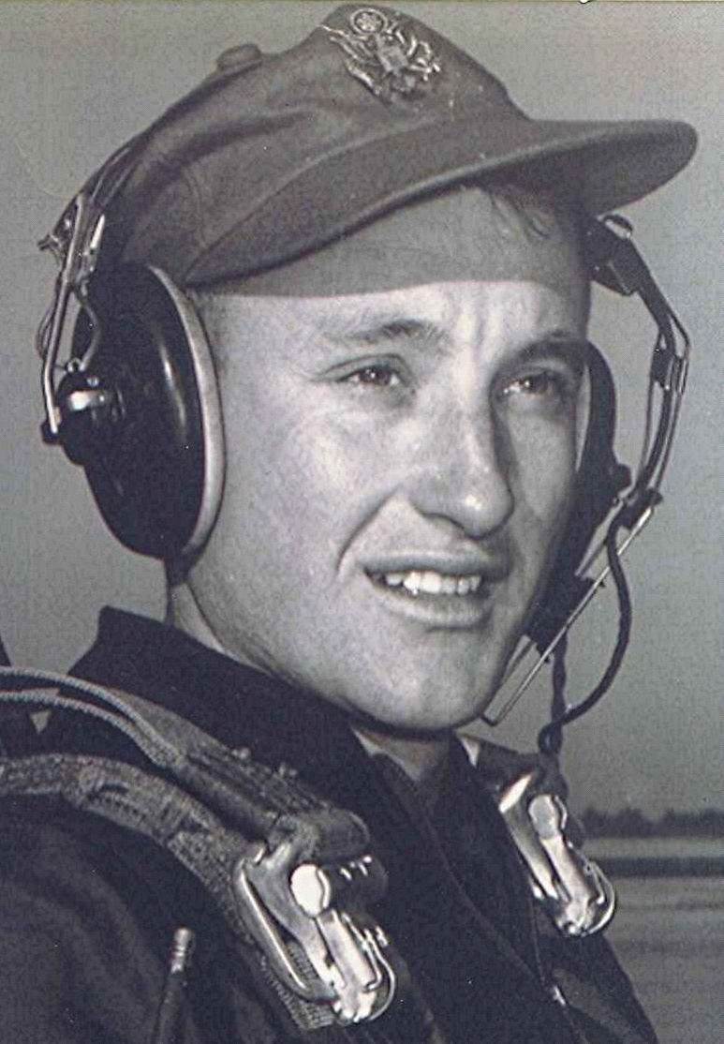
You from Bearden?
Abe Lemons, the basketball coach at the University of Texas, used to always have a line or two to crack up the reporters and fans. When he came to play Arkansas, he commented that the best thing about playing at Fayetteville was that the other team had to stay there and his team got to leave town. During those memorable contests at Fayetteville whenever a referee made a call that Abe didn't like he would shout out, "Where did they get this referee? He must be from Bearden."
I don't know who put Abe up to that. Maybe he had been to or through Bearden. To or through is a distinction without a difference. About the only other place that would be easier to miss would be Holly Springs—or Smead. But I stray off subject. I have wondered why I take such pleasure in disparaging Bearden. Could be from the rivalry that existed back when the two teams sometimes played basketball. But that doesn't meet the test, since Sparkman also played Fordyce and I didn't feel that way about Fordyce.
After long and careful thought, I have decided that it goes back a long time. Back to when I first started to school at Holly Springs. Back to when some families in Holly Springs, who, despite living in Dallas county, found a way to send their kids to Bearden instead of Holly Springs and Sparkman, where the rest of us went. I figured the reason was, they thought Bearden was superior to Sparkman. And maybe I did too, unconsciously.
But I would never admit that. The only way that I could see Bearden laying claim to superiority was that they had a roofing plant that smelled the whole town up, and more trains ran through there on the Cotton Belt than did the twice-a-day train through Sparkman.
Imagine my distress when, years later during a visit to Holly Springs, my brother's granddaughter comes into the room dressed in a cheerleader's outfit emblazoned with the Bearden emblem. Turns out that most of his grand kids went to Bearden. Makes one wonder what the younger generation is coming to.
A great philosopher once said, "Remember this: No matter where your go...you are there."

