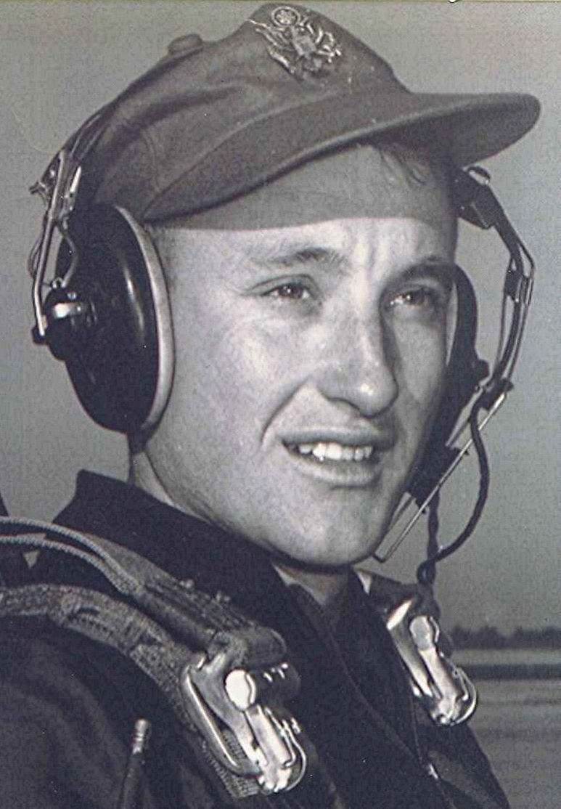
Thoughts that come at the end of the day
September 1996
Sometimes on quiet nights, when thoughts of childhood and Mama and Daddy come on whispering wings to carry me back, I remember with great poignancy:
How Daddy and I would hoe the corn on those hot afternoons in July until our backs and arms ached. How he would decide it was time to stop and rest and we would retreat to the shade at the edge of the woods alongside the field. There I would lie on my back, the blades of grass and weeds tickling the back of my neck; straw hat over my face to shade my eyes from the light. With my eyes nearly closed, the prisms of light penetrating the pinholes in the hat cast a kaleidoscope of images before them. The gentle breezes occasionally stirring the leaves above us in a welcome but brief current of coolness.
Sometimes, neither he nor I spoke and there was silence broken only by the occasional call of a bird or rhythmic sound of insects in the summer heat. I look back on those moments as some of the most memorable during the brief years that we were together on earth. I treasure them, remembering how all-too-soon he would summon me from my reverie and we would take up our hoes and go back to work in the fields.
Someday, I will be there with him again, resting in the shade beside the fields of Heaven, across the river.

