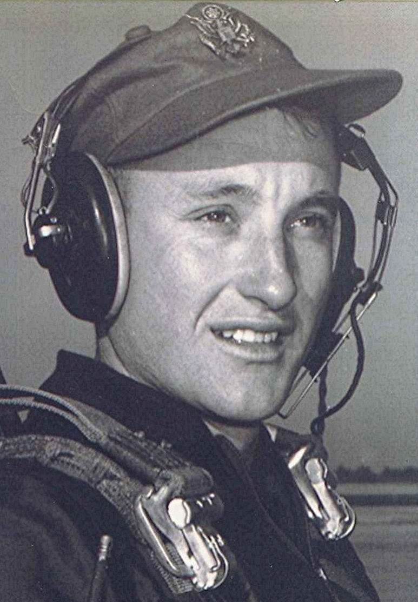
Memories & Candles
http://www.tributes.com/obituary/show/Richard-Boyd-Dodson-101624759
Condolences from assorted folk
Thursday, August 21, 2014
Jane, I remember both of you from school; he was 1 grade ahead and I think you was one behind me. I always liked both of you. you and the rest of your family are in my prayers.
Posted by: Lndell Abbott Hughes - Fordyce, AR - friend Sep 11, 2014
Jane, I have fond memories of our relationship when working together in real estate. Remember the Halloween party? Fun.
I am sorry for your loss of Boyd. Would love to read some of his writings. Will be remembering all of you in prayer. Billie (& Harold) Roberts
Posted by: Billie Roberts - Sherwood, AR - Friend at Sherwood Realty Inc Aug 30, 2014
Poppa was the man who gave me the first cooking lesson I remember: making grilled cheese sandwiches at an age when I could barely see over the avocado green stove in the kitchen where our family spent so many holidays. He gave me my first driving lesson: on one of his collection of riding mowers and tractors around the Dyer property, gathering fallen sticks and tree limbs in the "Go Jane" trailer. He even taught me a little archaeology, when we would dive into the past, in the furrowed rows of his freshly-plowed tomato garden, and be rewarded by the appearance of a flint arrowhead.
In all of these lessons and countless others, I also have strong memories of his care and caution: watch out for this or that on the stove, slow down that tractor and put on the brake, wear this hat and gloves in the garden; he was a teacher and a guardian. I still love cooking, and I always turn the pan handles in towards the counter for safety. I drove the tractor a little faster when he wasn't looking back then, but I am a cautious and careful driver today. I even wore a ridiculous broad-rimmed hat when I'm working in the little tomato garden I planted outside my own house this summer.
Poppa's desire to pass on knowledge was reflected in his intellectual curiosity and his countless written words. His desire to protect was reflected in his 21 years of military service and the responsibility he took on himself to care and look out for the neighbors in his community, and the members of his family.
His lessons and his care live on in everyone who knew him in very real and tangible ways.
Posted by: Russell Carey - Little Rock, AR - Grandson Aug 26, 2014
Boyd, when you came to Sparkman school you would write a novel and we would set on the coal pile and you would read the latest chapter. You were such a good story teller. We all loved your book reports they were so good.
I have so many memories of school and later when you retired. You were a true friend. Don
Posted by: Don Mann - Siloam Springs, AR - Friend Aug 25, 2014
So sorry about Boyd. Wish we had stayed in contact the last 26 yrs. we are in same place, same phone number. Our prayers for you and your family
Posted by: Ernestine Grooms - Sherwood - Friend Aug 24, 2014
Sharon, I'm so glad I had the opportunity to meet your father. He was a delight to talk to that day we dropped in on your parents to visit. My sympathies to you and your family at this time.
Rosalie
Posted by: Rosalie Colley - Hartman, AR Aug 24, 2014
Since Boyd was 4 years older than me I don't remember ever having contact with him, one on one. I had read some of his writings and we begin an email relationship. Those contacts made me become very fond of him. I know all of us that knew him will no have a large void in our heart. Every time I see an old C-7 I will remember him and Phu Cat, Vietnam...
Posted by: James A. Hunter - Harrisonville, MO - friend Aug 24, 2014
May God Almighty wrap His loving arms around you all during this time.
Posted by: Penny Shawn Parham - White Hall, AR - In-law and Friend Aug 24, 2014
I remember how Boyd was always ready to help his fellow class mates and never had an unkind word for anyone.
If there was a task that needed to be done he was there to help. His wisdom was very apparent even during his school years.
Posted by: Charles Randle - Springdale, AR - Classmate at Sparkman School Aug 24, 2014
Our sincere sympathy to Boyd's family. Thanks for your faithful service, C7 Pilot.
Posted by: Ed & Shirley Jestice - Alexander, AR - Friend Aug 24, 2014
Known only to me as Pop. Not only my Father-in-Law but my friend. In these last few years we grew to trust, honor, respect and love each other. We accepted each other with open hearts. Pop has been a brave man and a fighter. Your memory will be etched in my heart forever. I am going to miss you Pop; but, I know you are at peace and at home in Holly Springs with family, memories and God like you always wanted it. RIP Pop, RIP ....
Posted by: Lynn Edward Braswell - Maumelle, AR - Son-in-Law Aug 24, 2014


My thoughts are with you in this time of your sorry.
Mary Ellen
Posted by: Mary Ellen Curry - friend Aug 24, 2014
Jane and family, my prayers are with you during this difficult time. Boyd and I shared a lot of good memories the last few years. I cannot explain how much he has meant to me exchanging emails over the years. I will miss him greatly and know each of you will. We all can be thankful for the memories he leaves behind through his many writings. I am so thankful that I got to visit with him at St Vincent. God bless the entire family.
Bob Abbott
Posted by: Bob Abbott - Pine Bluff, AR - Friend Aug 24, 2014

