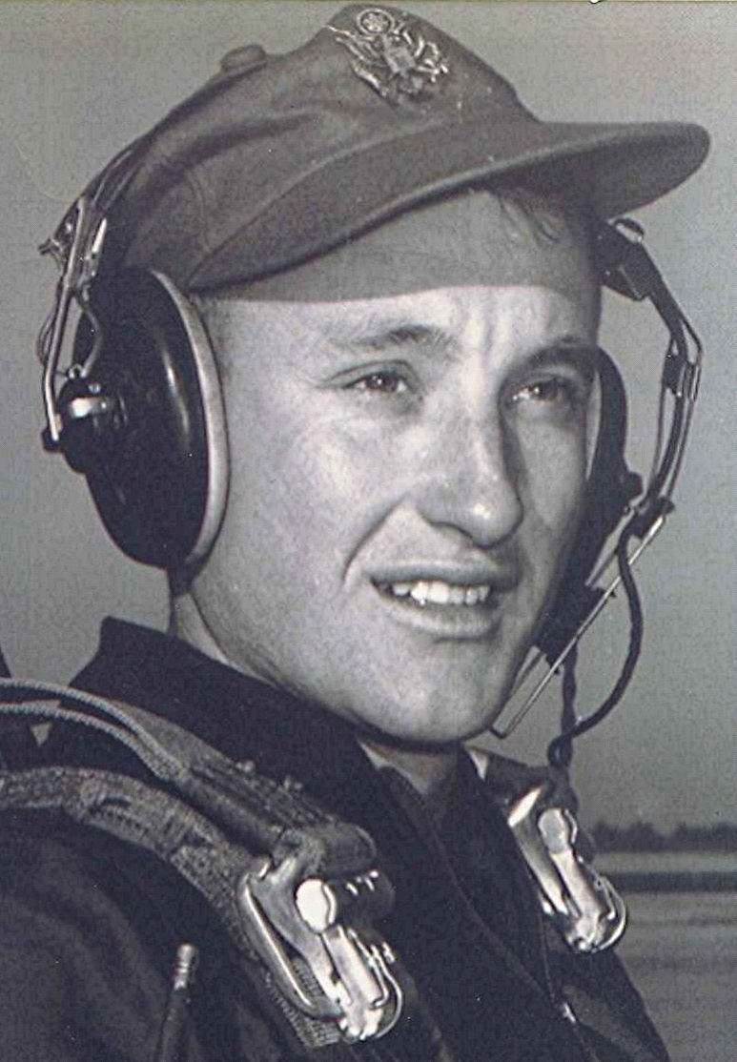
Memories & Candles
http://www.tributes.com/obituary/show/Richard-Boyd-Dodson-101624759
by Richard Andrew Carey
Thursday, August 21, 2014
Richard Boyd Dodson, 80, of Maumelle, Arkansas, USA, passed away Thursday, August 21, 2014. Boyd was a gentle and intelligent man, a military pilot who served his country, a writer at heart who treasured his memories, a man who dearly loved his family, a friend who kept the bonds strong through eight decades of time, and a valiant soul who steadfastly faced the challenges of his last years.
Boyd was born October 19, 1933 in Holly Springs, Arkansas, USA, to the late John Henry Dodson and Elizabeth Palmer Launius Dodson. It was in Holly Springs that he met Jane Rhea Lancaster, whom he married October 21, 1955. He joined the United States Air Force through the Aviation Cadet program, and was a commissioned officer, piloting bomber and cargo aircraft. He served a tour in Viet Nam and was awarded the Distinguished Flying Cross.
After his military service, he earned a degree in Industrial Management and worked in the field of construction before retiring. Boyd and Jane lived in Dyer, Arkansas, USA, for 26 years where he raised enormous gardens, served the community, and quietly assisted those in need. In 2012, Boyd and Jane moved to Maumelle, Arkansas, USA, to be closer to their children.
Boyd is preceded in death by his parents, his sister Johnnie Palmer Dodson House, his brothers Eugene Leander Dodson and Ferrell Emory Dodson, and a granddaughter Rebecca Ann Jones.
He is survived by his wife of 58 years, Jane Rhea Lancaster Dodson, his sister Mary Bell Dodson Mackey, his son Arlis Boyd Dodson and wife Rebecca Louisa Brannon aka "Becci" of Broomfield, Colorado, USA, and three daughters: Sharon Rose Dodson Champion of Russellville, Arkansas, USA, Diana Carol Dodson Carey Braswell and husband Lynn Edward Braswell of Maumelle, Arkansas, USA, and Jennifer Ann Dodson Jones and husband Timothy Louis Jones of Beebe, Arkansas, USA.
He leaves behind nine grandchildren: Dana Kate Champion, Russell Andrew Carey, Andrew Scott Champion, Jessica Lane Jones, Richard Mark Carey, Elizabeth Ashley Jones Franklin, Emily Jane Jones, Victoria Grace Jones, and Michael Boyd Dodson; two great-grandchildren: Gabriel DeWayne Franklin and Persephone James Carey aka "Percy"; and several nephews and nieces.
Boyd will be remembered for his beautiful writing, his quick wit, his gentle and strong hands, and his graceful determination.
The family would like to express a word of thanks to the staff of the St. Vincent Surgical ICU and Surgical Ward units, and the staff of Cornerstone Long-Term Acute Care Hospital for the kind and dignified care Boyd received during his lengthy hospitalization.
Boyd was a lifelong Methodist. In lieu of flowers, please consider a donation in Boyd's honor to the Wounded Warrior Project or the National Parkinson Foundation.
Visitation will be Monday from 12 PM until 1 PM at Benton Funeral Home in Fordyce, Arkansas, USA. Funeral services will follow at 1 PM at the Benton Funeral Home Chapel. Burial will follow at New Holly Springs Cemetery, Holly Springs, Arkansas, USA.
To sign the online register visit www.bentonfuneralhome.net .

