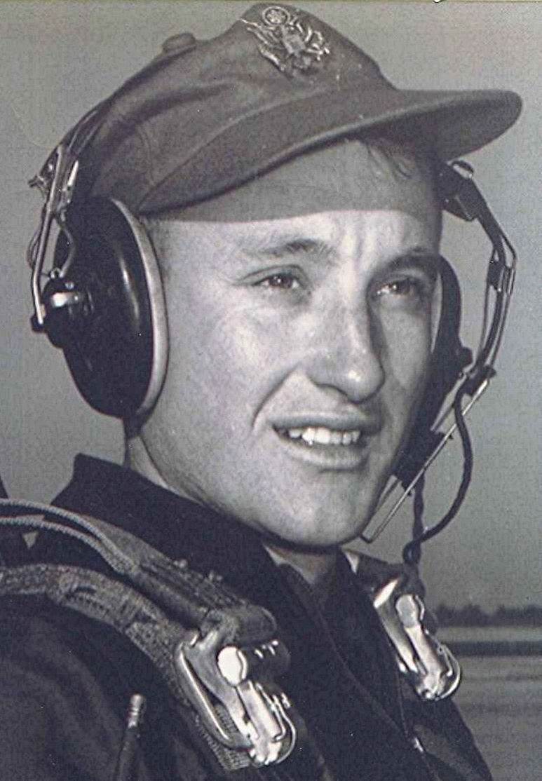
The Gathering
(thoughts of one suffering from incurable nostalgia)
The air turns mild in the evenings. There is a hint of the coming of fall and soon we will hear the geese flying South. The summer is over and done. So many things we planned with enthusiasm in the spring, when the earth was green and the flowers blooming; such as our intentions to contact old friends and reestablish links with those who have gone down paths apart from ours.
Why, this desire to renew ties from an earlier time, when our youthful minds were filled with idealism; with hope and confidence of what lay ahead? Who knows why these thoughts fill our idle moments and quiet nights, as some marker from the past reawakens our memories. A letter, a newspaper article, news of Sparkman; each revive thoughts of those with whom we spent some of the best times.
At some point in life, when we are old enough to cast aside youthful illusions of immortality, we may look down the pathway and see the end. It is then that we pause to review our life; from its beginnings to that day when, for us, the final bell tolls.
What do we make of this, the mystery? What fate brought us together in time and space, at a small school in a place called Sparkman? I would not change it, for I am satisfied that this was meant to be. Call it fate; call it divine will. Whatever the reason, I feel blessed; having been there with you. Some of us make the, perhaps exaggerated, claim that ours was the best. Or is it really such an idle boast? I have heard others make the same case for theirs. Let them have their myths; we won't deny others their illusions.
I look around me as we gather. I see the same friends that were back there. We haven't changed—not much. We still have the same mannerisms, the same reticence or outwardness as then. Yes, our hair is somewhat thinner and sometimes grayer, and the lines appear on what were once unlined faces. These indicate the untold trials that have befallen us as we have come this far. Beneath those lines, a hundred or perhaps a thousand, stories of hardship, struggle, and triumph could be told.
But that's not why we are here. We come to celebrate because we share a common tie to the past, with memories and recollections that have remained with us from those days. By our coming, we create a small island in an ocean of time. Here, for a few hours, we lay aside the concerns in our own lives and renew our spirits as we renew our friendship. It is such times as these that reinforce my belief that sentimental feelings are so significant in the human experience; we look back with pleasant memories of the good times we once knew, with friends from long ago.
at the end of the day...
When the sun is low
and the shadows have lengthened,
we prepare to depart from the fields of life.
Our work has ended;
we look back down the long rows behind us
and think not of the hours of labor.
Instead we see the beauty of the field
and the promise of harvest.
Our thoughts turn homeward;
across the meadows a bell sounds faintly…
calling us home.

