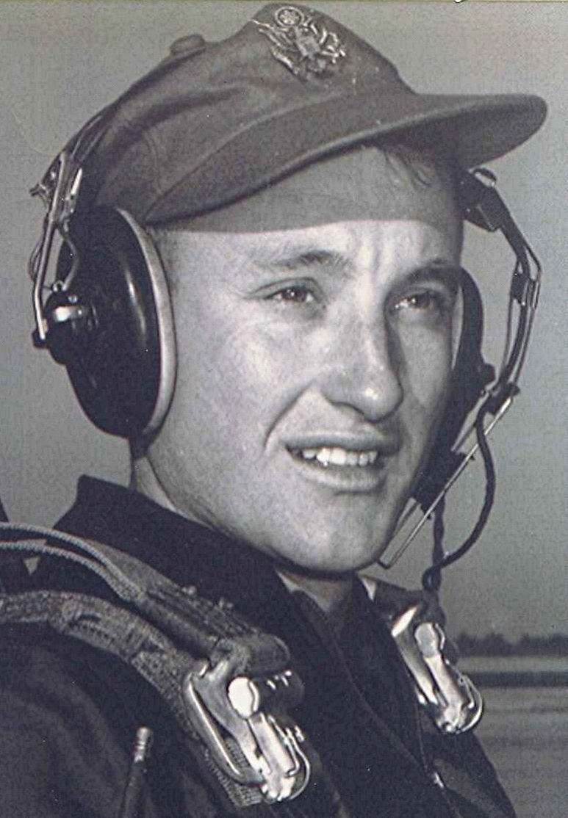
“You Can’t Go Home Again”
By a member of the Class or 1951
Fall, 1976
Written after attending their first class reunion, where he encountered the high school sweetheart he hadn't seen for twenty-five years.
“You can't go home again.” He recalls the words from somewhere back in the past, perhaps from the title of Thomas Wolfe's novel⁽¹⁾. They linger in his memory and haunt him, even now. Through the years his boyhood memories remained to sustain his life, especially in troubled times. Then, his thoughts returned to a more placid place; to events and to people who are forever young, filled with vitality and innocence. Back to his high school days; the red-brick school and the small class of twenty one—eleven boys and ten girls. Sharing in the optimism that beyond school was a world to conquer; a life to live, adventures to taste.
Instead of sweet victory, bitter dregs of defeat were often the fare. The burdens of marriage, leadership, job, and fatherhood. The thousands of 'oughts' that loomed dark and oppressive. But always available in the midst of the chaos was that quiet retreat with admiring friends, chums, and sweetheart. A world in which he was a leader—respected and appreciated. A world whose citizens were seventeen.
As the speedometer clocks the miles from Little Rock, Arkansas, to DeGray State Park, Arkansas, a mixture of expectation and dread builds within. Wife driving, passenger deep in thought—of the past and the years that have slipped away; of former friends that have become strangers. Soon, they will meet again.
He remembers the night they said goodbye at her front door, ending a relationship that was doomed from the beginning. He, apparently having some subconscious need to pursue the unattainable one, and she—he could only guess what motivated her involvement in such an on-again, off-again, roller coaster relationship. Then, to end it all without any communication between them as to why they had come to that moment; only a mutual and unspoken recognition that it was over. Over, but not finished; ended without ending. Like a book whose words cease in the middle of a sentence; with only blank pages left to reveal what was or was not. Though healed by the passage of time, the scars were a reminder of that night, so long ago.
The turn from interstate to access road; to state park and lodge. The bags removed from the trunk, followed by a hesitant and cautious entry into the lobby. "Oh yes, the Sparkman group.. Twenty-fifth reunion... A few have arrived." Within, a combination of fear that she would not be here—and that she would. What would she think when she saw him once again? Would he be overwhelmed at the sight of her? What of the others? Would they find things to talk about after all these years?
The first two he had seen the past year, but only those two. After a few brief words of greeting, the vigil began; waiting, identifying, guessing who's who. The adjustment to the erosion of years upon once-youthful faces; the streaks of gray: the extra pounds. But surely not she—as he remembers the vivacious teen-ager from twenty five years before.
Then, a stir at the door. There stands someone older, with gray-streaked hair. Uncertainty and shock overcomes him and he turns toward the wall to avoid meeting her eyes. When it becomes obvious that he must make the move, he offers a hand. In response, a reluctant show of recognition, with her husband standing by. A diffident, "How are you"? A few words of small talk, then she moves on to another group on the other side of the room.
The automobile wends its way back home, the speedometer clocks the miles. Wife driving, grieving passenger deep in thought; memories once vibrant, now in ashes. Ghosts of youthful dreams now laid to rest; the last page completed, the book closed...
End

(1) “You Can't Go Home Again” is a novel by Thomas Wolfe

