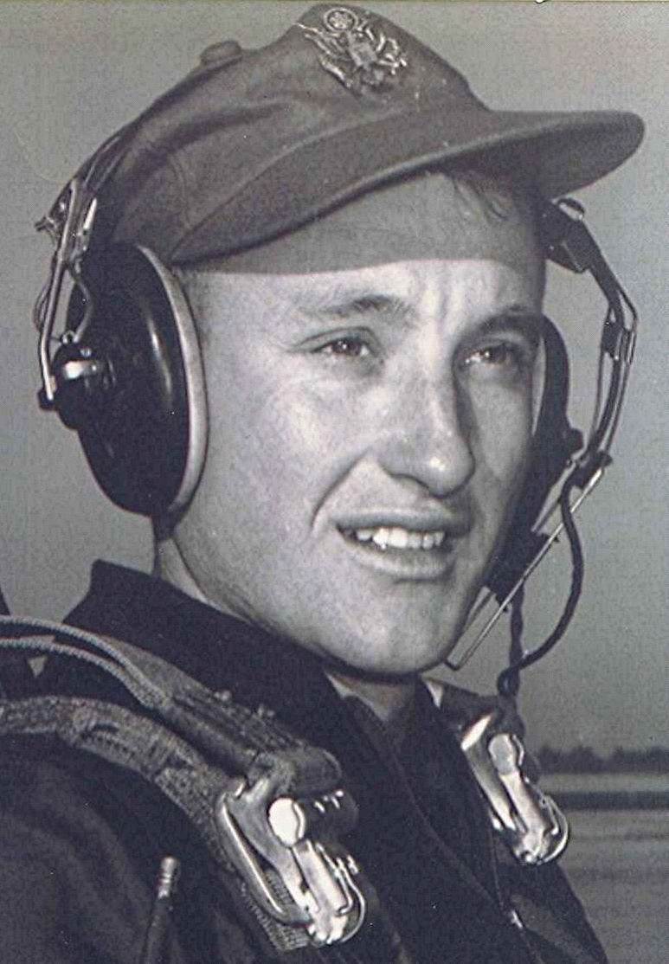
The long road home
(When young love pays the price)
It was in the spring and planting time had come. He was eighteen and the nights were warm and romance flowed in his veins. She lived over beyond Sparkman, Arkansas, where they both had attended high school. It was up toward Dalark about four or five miles. He had borrowed his brother's Dodge sedan, with fluid drive and soft, cushioned ride. The car was nearly new, bought recently to replace the Studebaker Champion that hadn't endured the gravel roads on his brother's mail route. He could have taken his Dad's pickup, but he wanted to drive around in a new car. It gave him a sense of being someone of some substance and means.
As he traveled the miles to Sparkman and beyond, his mind produced visions of a small white house and picket fence. Inside, she tended things while young children ran about the yard, investigating the flowers that grew in abundance. He arrived from the fields at the end of the day, tired but happy, and she greeted him with an embrace and words of tenderness as they proceeded to the table and ate the meal she had prepared for him and the children.
She waited for him inside the front room of the small but neat white house that sat on the west side of Number 7 highway, near a small stream. He felt that slight unease which comes from approaching the home of a father who seemed not too fond of the youth who dated his daughter. Her mother, while always kind, appeared to be neutral toward him. He suspected that their reticence might be due to their warm feelings toward his rival, a slightly older fellow who was already in college at Southern State, in Magnolia. His family, quite prominent in the community, lived on a prosperous farm near the church she attended.
His rival was a Baptist; so was she. Rival taught Sunday school, attended youth group with her each Sunday evening and, according to her, sang beautifully. Of this he was jealous, as his own voice was dreadful and he couldn't read a note of music. Besides, he was a Methodist—although she said she didn't hold that against him. Why, her sister even married a Methodist and joined his church. However, she had subtle ways of letting him know that the Methodists didn't quite measure up to the Baptists when it came to meeting all the requirements.
He cast these thoughts aside as he pulled up in front of the house and stopped. He got out and proceeded to the front door and knocked. Most times she came to the door herself, or sent little brother. Sometimes he had to wait while she finished doing whatever women do prior to being ready for a date. Seldom did her mother enter the living room, perhaps sensing that to do so would make the young man even more uneasy. This night she was ready when he arrived, and they were soon on their way. Time passed quickly while he was with her.
After the movie they drove home by a circuitous route, stopping to enjoy the moonlight as it bathed the freshly planted fields. The scent of honeysuckle drifted through the open windows of the car. There was talk of dreams and plans for the future. When the conversation turned to the subject of the two of them together in the coming years, she seemed to drift away, to become somewhat reserved about such matters. He chose to disregard that, to just enjoy the pleasure of being in her presence for those few hours.
By the time they arrived back at her house it was after midnight. His idea was that as long as they were parked in front of the house, there was no curfew violation. They exchanged pleasantries and engaged in conversation about things mundane and not so mundane. He, always keeping one eye on the front door lest her father appear, wearing only a nightshirt and a deep scowl, to order his daughter inside—but that never happened. After several mini-partings and more conversation, he reluctantly left there around one thirty or two o'clock in the morning.
Once he started down the road toward Sparkman, sleep threatened to take over. He drove for a while with his head out the window, the cool night air brushing his face. The rejuvenation lasted only a few miles before it had to be repeated. Along the way, the houses were dark, their owners having gone to bed hours ago. It was a week-day night and another work day beckoned them early in the morning. He entered the outskirts of Sparkman, the street lights casting a soft glow in the darkness. The asphalt street, which lasted only a few miles while inside the city limits, was a welcome relief from the loose gravel and the dust of Number 7 highway. On through Sparkman he drove, then southeastward, down the gravel highway to Holly Springs.
Several miles beyond Sparkman there was a noticeable swerving as the car headed down the hill by Silliman's store. With chagrin, he recognized the all too familiar symptoms and stopped to check the tires. One of the rear ones was flat. He opened the trunk to remove the jack and spare. To his dismay, the trunk was empty. Where was the spare? Why would his brother have removed it from the trunk?
Reluctantly, he turned off the lights, locked the car and started walking toward home. Above, the sky was black except for a few stars, with no sign of the moon that had shone brightly earlier that night. Ahead, he could barely distinguish the tree lines on either side of him which he used to outline the road ahead.
His feet crunched on the loose gravel as he walked. The noise made it impossible to hear if someone should come up behind him. He left the comforting presence of the store and the nearby house as he proceeded down the road. His thoughts now turned to the miles that lay ahead of him; the darkness and, above all. the knowledge that he must cross Tulip Creek bottom. It was some two miles across, with many bridges and deep woods.
The first miles were not hard. There were several fields and an occasional house along the road. Strange, how one can draw a sense of comfort in knowing that within the darkened houses, there were people who, although sleeping, represented an imagined measure of security to the lone passer-by.
Later, the landscape changed as he descended the long steep hill into Tulip Creek bottom. He had long since passed the last house, the fields now replaced by the dark and sinister forest. The middle of the road, where he had elected to walk, seemed much too close to the woods on either side of him. He took no comfort in the realization that the closest house was now miles away should he need help. Involuntarily, he recalled the speculation that there might still be one or more wild animals left from the large numbers that once roamed these dark bottoms. Perhaps a bear, panther, or who knows what? The only sounds he heard were those of his footsteps, crunching the gravel. The noise sufficient to warn any adversary of his approach. His mind produced images of scary things of which he had not thought since he was a child. He tried to quieten the pounding of his heart, but his thoughts wouldn't allow it.
For what seemed hours he walked on through the darkness. At last he could tell that the bottom was coming to an end. Suddenly, he sensed something up ahead. He stopped and listened. There was something and it kept coming! He decided there was no point in standing still and letting whatever it was come upon him as he stood. With legs trembling, he forced himself to walk toward the oncoming sound. In the darkness he perceived the form of an animal coming toward him. Finally, when within a few yards of him, it veered off the road and disappeared into the woods.
His pounding heart gradually subsided as he left the bottom and proceeded up the hill toward Holly Springs. A couple of miles farther along the road, the countryside began to feel less hostile as he once again got closer to where he knew that people lived.
After leaving Tulip Creek bottom, he began to think about the road from Holly Springs to his home. From town, the road went down a hill past the Methodist church and the graveyard. All his life he had read and heard tales of horror about graveyards at night. His only alternative was to take a short-cut by the old school house and follow the dim and little-used road which crossed a branch bottom filled with water and thickets before it joined the road to home. He decided to take the short-cut rather than pass by the graveyard in the night.
Once past that, there was yet another creek bottom, albeit small, to be crossed before he got home. Chapel Creek was about a mile from the house. By the time he arrived there, the first light of dawn was showing in the east. By then he had become accustomed to the night to the extent that the creek bottom seemed almost to welcome him, now that he was nearly home. He arrived at his house at dawn, having walked the eight miles from where he left the car. His brother was already up and starting his day. The two of them took the pickup and a spare tire and retrieved the car. On the way back he met the school bus, filled with kids on their way to Sparkman High School.
End

