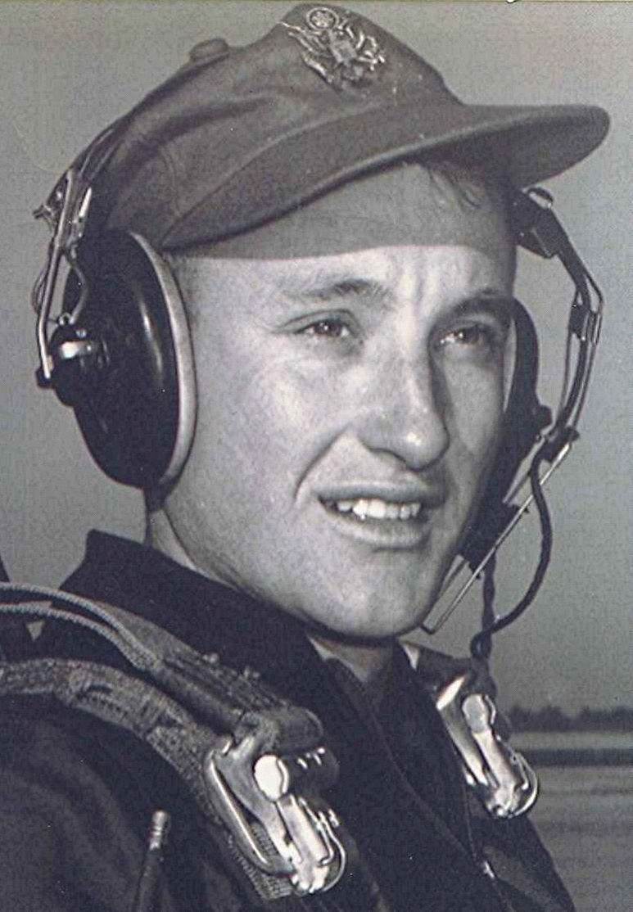
Memories
upon returning to Ben Few campground
August 22, 1990
I often wonder about existence and purpose, birth and death, as I make this journey through life. Sometimes, for a fleeting moment, an opening in the veil provides a glimpse into the mystery and beyond: a moment when there is a resonance with life, death, and eternity.
The radio announced a temperature of one hundred that August day, as I drove south down Number Nine highway toward Princeton, Arkansas. The air conditioner struggled to beat back the noon-day heat. I turned west in Princeton, now a ghost of the town of my boyhood days in Dallas County, Arkansas. Only a small store and a few houses remain. I recalled that Ben Few Campground, an old Methodist camp-meeting site, was out this way from town.
As I drove in that direction, I did a quick calculation of the years since I had been there. It was about forty years ago when I last attended camp meeting with Mamma and Daddy. I would have been in high school, as I remembered that one of my teachers from Sparkman was also there. For what seemed miles, I saw nothing familiar along the road from Princeton; only the forest, whose trees silently framed the landscape ahead. Just as I had decided to turn and go back, around a curve there appeared a sign announcing the road to Ben Few.
Proceeding down the unfamiliar paved road, I recalled the old one with its sand and its ruts worn by traffic. Then off to the right, the camp came into view. At the sight of it a wave of memories rolled in. The same oak trees as before; the rustic cabins, though more numerous, looking just as when I last saw them. Most vivid among my recollections were those of the tabernacle, still standing in the small clearing exactly as I remembered it, waiting for the annual crowd of worshipers and the preaching.
I stopped the truck and walked to the bottom of the hill, to the spring which I had almost forgotten. It is now surrounded by a concrete floor and a low wall, built sometime in the intervening years. Its flowing water joined the small stream just beyond. The stillness and heat of the August day, the damp air surrounding the spring, all carried my thoughts back to some forty years before.
I looked about for a can or cup, something with which to take a drink from the spring. I felt compelled to do that. Somehow that would make my journey here seem complete. After that, I walked up the hill to the open-sided tabernacle. Hesitating there beside it, I looked inside at the familiar old platform, where ghosts of preachers from the past exhorted the silent benches that sat with reverent attention. The familiar sawdust floor beneath them, just as it was back then.
As I stood there, I could see the choir, along with the preacher and the congregation. Then for a brief moment, Mamma and Daddy were there with me. We did not speak, only a long and poignant silence as I recalled the last time we were together at Ben Few.
With a heart full of memories and longing for things that are gone forever, I lingered beside the tabernacle, its weathered permanence providing a bridge to the past. I wanted to stay, but knew that would not do. Slowly I turned and walked away. The truck door closed beside me. With a deep sadness and sense of loss, I turned the pickup toward the road, leaving behind the sacred hill with all it's memories.
End

[Ben Few Campground is classified as a locale in Dallas County, Arkansas, USA.]

