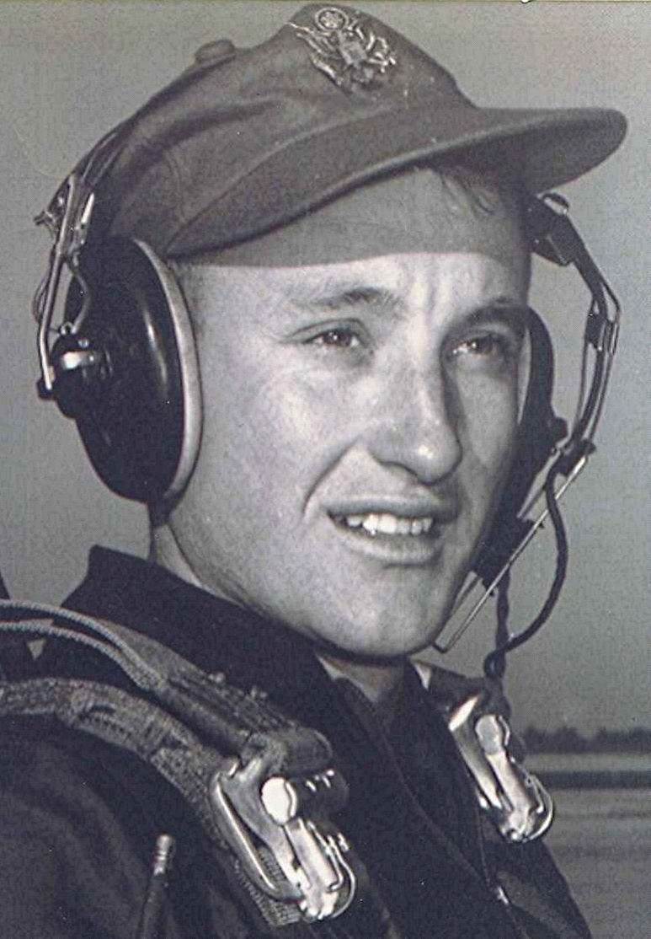
Sister
There is a part of my life which contains a tragedy so painful that, even after forty-five years, it is difficult to write about. My memories of Palmer⁽¹⁾, who was known to us as Sister, are mainly of her poverty, her suffering and, ultimately, her death from cancer. From the time that I can first remember her, she lived in poverty. I have been at her house, more times than I care to remember, when there wasn't food for the next meal. Her husband, who was often away, seemed never to provide for the family. For a period of time, she lived in an old house at Holly Springs, Arkansas. Daddy and Mamma would take me there to stay with her when she was alone with the children.
Quite often, Daddy would go get her and the children and bring them to our house to stay. I realized later that those were the times when she had no food. I was at her house one time when she sent her oldest son, Jerry, to the grocery store for some things. He returned home empty handed and shortly thereafter the store owner, Marvin Ramsey, drove up to the house and told her that he couldn't let her have anything else on credit, the bills having been unpaid for so long. Her husband was away, somewhere, at the time. I remember her crying as Marvin drove off. I was too young to realize what I had witnessed, and how painful and degrading it must have been for her.
It was about this same time that a mole on her leg became sore. Mama, Daddy, and I took her to Camden to the clinic. Dr. Byrd examined her leg, then left the room. Shortly, he came back with another doctor and they both examined her leg under a reading light with a flexible stem that they took from a table in the room. Dr. Byrd asked the other doctor if he saw what he did and the other doctor said, "Yes." They then told her that she had cancer. I didn't understand the terrible message in that announcement, only that the news caused her to cry. When I think of those dark moments, even today, it is painful to know that in the deepest crisis of her life, that she had no one to help her through. It always seemed to be left to Mama and Daddy to help her what little they could.
There wasn't any state or federal assistance as we have now, to pay the medical bills. Somehow, they arranged for her to be admitted to University Hospital in Little Rock. We didn't get to be with her much, due to the distance. We didn't have any transportation that could be relied upon to take us that far. Sister came home some time later, after they had removed the cancer, but she never recovered. Her left leg remained swollen very badly and the disease spread throughout her body until she died, in 1946, at the age of twenty nine.
The last time I saw her alive she was staying with her husband's parents. They came to the house and asked Mama and Daddy to come and help bathe and dress her for the trip to Little Rock. I'm sure that Mamma and Daddy knew that she would never come home again. At that time she was pregnant with her fourth child; the third having been conceived and born while she was sick with cancer.
Two weeks later she died, alone, in University Hospital—the welfare hospital in Little Rock. Her baby was taken by caesarean as she lay dying. I don't know, nor have I ever asked, what were the origins of that tragic marriage.
When I stand by her grave at Holly Springs, I know that if ever there was someone that deserved relief from life's sorrows, it was Sister. She never had a decent chance at life while on this earth. I wonder if she ever experienced a day of happiness. Dear God, she is now at rest.

(1) ~ Palmer, aka Johnnie Palmer Dodson, married Howard House.

