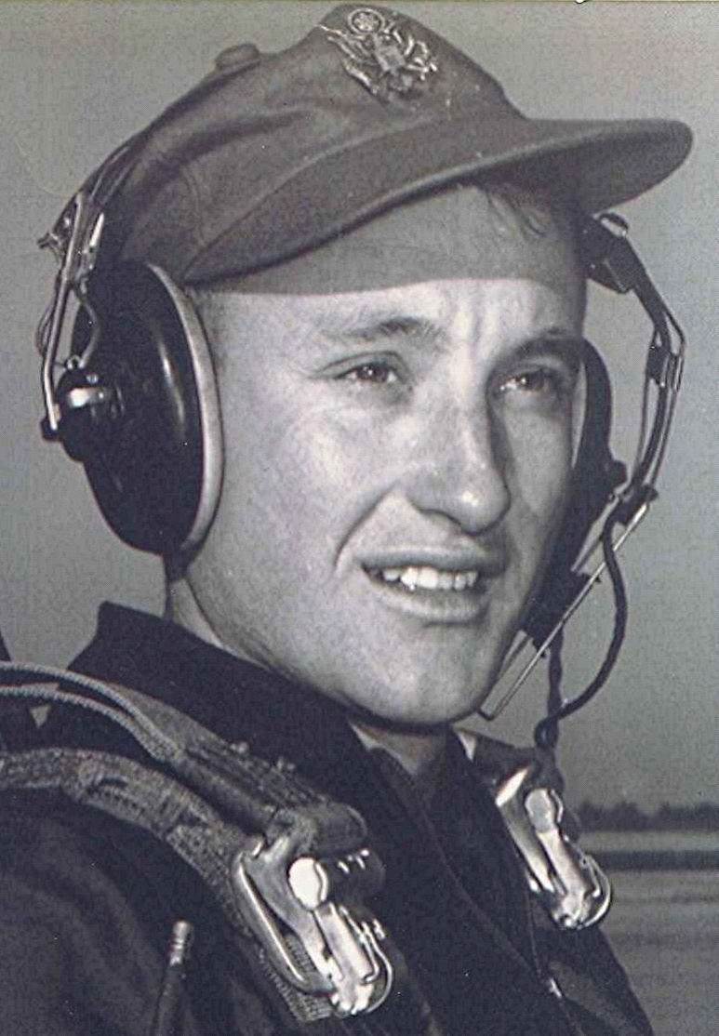
Homer
Fall ~ 1976
In the south Arkansas community of Holly Springs, Arkansas, Homer stood apart from the average church-going person, who was more or less the norm for the 1940's. Insofar as I can remember, this red-headed rawboned individual never blessed church with his presence. I mention that because individuals like him were rather unique, when compared to the rest of the rural community. It would have been a significant event if he had suddenly decided to start attending. Homer had attained the reputation for being the community's principal hell-raiser, drinker, and weekend-disrupter.
He supported his family on the very modest, some would say paltry, income he received from working with his team of mules in the logging woods. The work was arduous and demanding, beginning at dawn and not ending until well after dark. From Monday through noon Saturday Homer drove his team hard, while plying them with a supply of curse words that seemed inexhaustible. He punctuated the expletives by cracking the long ends of the leather lines upon the mules' hind quarters, as one would use a whip. At the end of the day, the mules and their sweat-drenched driver were at the point of exhaustion.
After drawing his paycheck on Saturday, Homer often began a week-end of heavy drinking. His temper, which he had difficulty controlling when he was sober, seemed to be unleashed by alcohol. Homer sometimes went on a rampage, challenging anyone present to engage in a fight; on those occasions when the challenge was accepted, he often lost the contest. I remember one time when he and another had a fight inside the country store; a thrown coke bottle barely missed Homer's head, then made a dent in a store shelf. Eventually, the rampage ran its course and was then transformed into a deep slumber which sometimes stretched over into Sunday. In spite of the drinking and the fighting, Homer was always at work each Monday morning.
During this time, there was a member of the community who was dying from cancer. All too often in those days, there was no money and no possibility of hospital care. Here, the death-watch was maintained at the dying man's home; it continued for months. At first, there were numerous relatives and friends to assist in the bedside vigil, but as time wore on they became fewer and fewer-until there was only one.
Each weekday evening, after he had fed the mules and had eaten supper, Homer cranked his old Model-A truck and traveled the six miles to the dying man's home. There he remained, often until well beyond midnight. He continued this nightly watch through the long summer and on into the fall, when cancer won the battle and the man died. At the cemetery, friends and neighbors in the community gathered to offer his wife their condolences. She was overheard saying, "There is someone in this community whose kindness I will remember as long as I live; it is Homer..."
Homer later became unemployed when newer logging methods replaced the mules he drove. He moved to a town some forty miles away and worked there at a mill. I have no evidence that the working and drinking ritual ever changed until his death, several years ago. Homer, in many ways, represented the rest of us in our struggle with the dark side.
He, in frankness, laid his bare before the community; while ours, in many cases, remains our own private hell.
End

