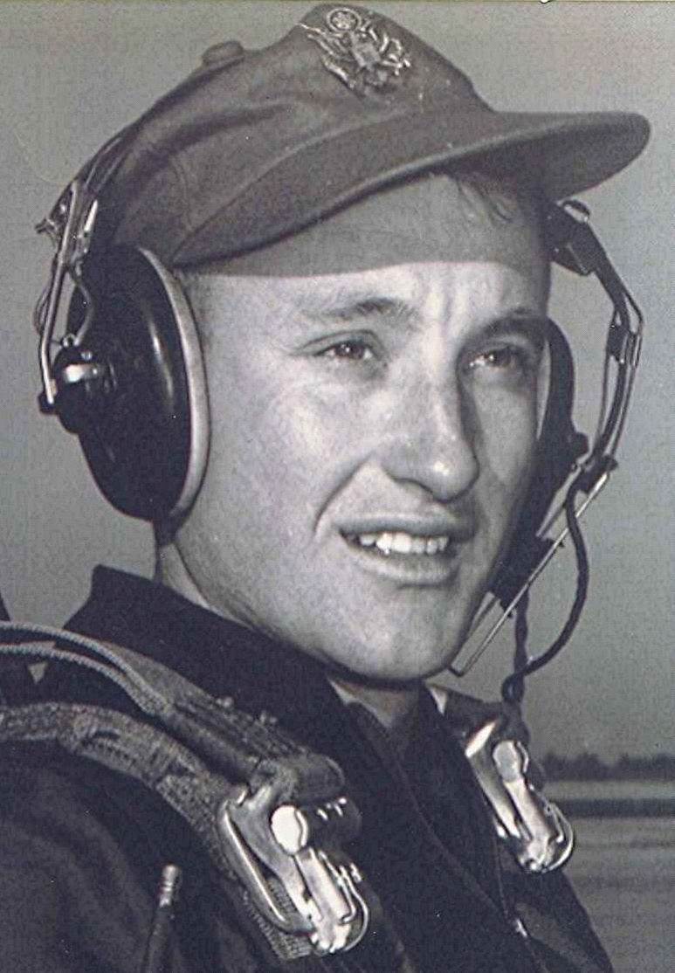
The Shadows Lengthen Fast

Reflections about people, places, and times now gone

foreword
The following is an assortment of things written over a fifteen year period; sometimes with a gap of ten or more years between efforts. They range from reflections on some unique people I have known, to the subject of romance and first love and the consequences. Others are thoughts that come to mind on a quiet night, or at the end of the day, when life's burdens seem unduly heavy.

