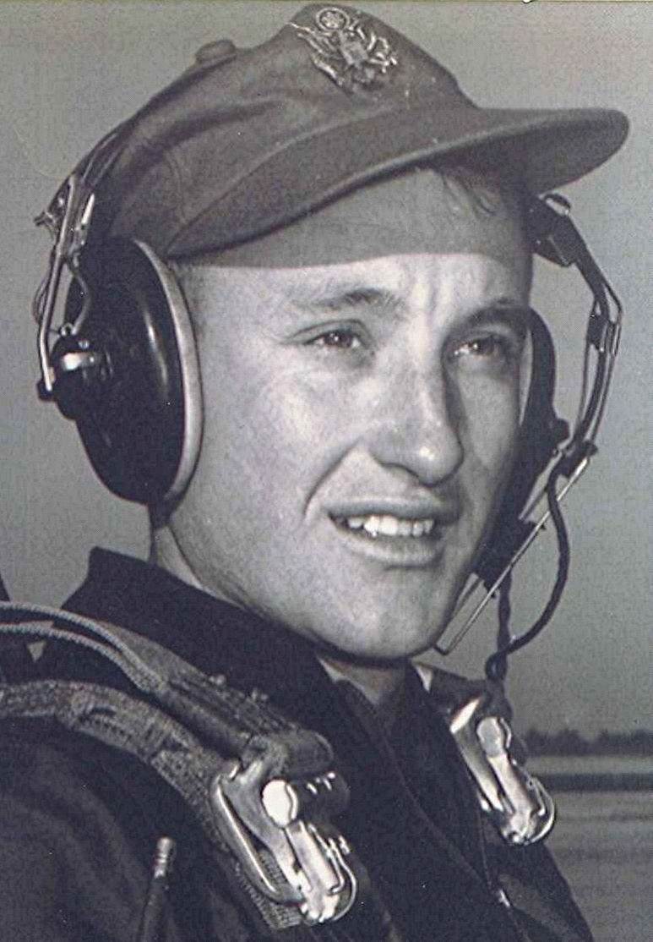
Lauterstein’s
In San Antonio there was a famous clothing store, "Lauterstein's." Lauterstein's was known throughout the Air Force for their fine tailor-made uniforms. There was a branch office at Bryan and, he guessed, at every other training base where new lieutenants graduated. With each graduation ceremony at Bryan, they saw the new lieutenants roaming the area who, only hours before, had been their upper classmen, now resplendent in tailored Lauterstein silvertans. During the summer, the cadets who were interested in buying uniforms were invited to Mr. and Mrs. Lauterstein's home in Bryan. There must have been several Lautersteins, since the one at Bryan was a brother of the Lauterstein who operated the store at San Antonio. Mr. and Mrs. Lauterstein were wonderful hosts; the guests thoroughly enjoyed the afternoon at their house, eating hamburgers and drinking cokes while they played, talked, and relaxed on the St. Augustine grass in the back yard. When they left, they felt as if they had just spent an afternoon with their own family.
From Lauterstein's, a new lieutenant could purchase an entire complement of uniforms, silvertans, and blues, complete with overcoat and wheel hat, with blue shirts thrown in. There was also collar brass and an expensive looking set of Air Force pilot wings. The total price for all this, three hundred dollars. Mr. Lauterstein would let you have the uniforms on a monthly payment plan, extending over several months. Except for the more conservative and sensible, many of the graduates had signed a contract for the tailored uniforms. His room mate, Robert Brown, who was returning to the Air National Guard in California, purchased uniforms at the clothing sales store on base for less than one half the Lauterstein price. Although the Lauterstein uniforms cost well over a month's pay, he later had few regrets. Unfortunately, he had gained enough weight by the time the last payment was made, that the buttons were beginning to strain. Meanwhile, he was one well-dressed Air Force second lieutenant.
October 17, 1955
The gathering was small; the ceremony brief. It took place in the cadet club. Colonel Gunn made a short speech, followed by one or two others, of which he only remembers a word or two, concerning the runway behind you and the space above you—both useless in the aviator's world.
The top graduate was introduced, followed by the top student flier and the top student in academics. Then he and a few others were presented with Distinguished Graduate certificates, based on their combined grades in military training, flying and academics.
After that, they lined up and proceeded across the stage, where they were handed their gold bars and silver wings. Their mothers, fiancées, and sweethearts awaited at the side of the stage. The newly-won badges and insignia were proudly pinned upon their tunics. This, followed by applause. In this brief moment, they all shared in the triumph, in the victory. For most of them, it would be their last time together. Outside, the skies were never bluer; the future never brighter.
End

