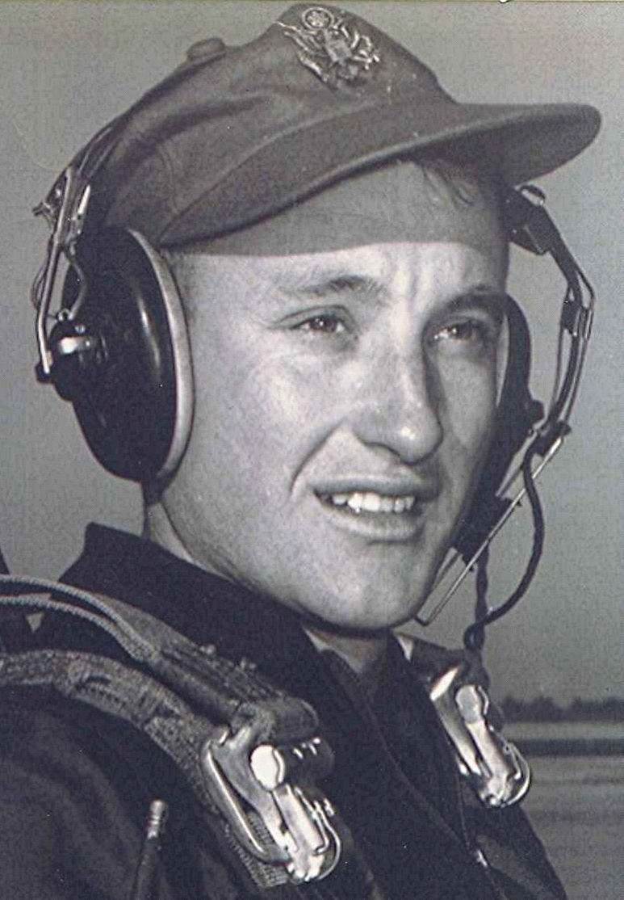
The end is in sight
The graduation ceremonies of the ones ahead in the program gave hope and enthusiasm to the students in the later classes. For they knew that some of the newly graduated lieutenants had struggled to make it through. If they made it, so could the others. With advancement to jet airplanes, there came a certain amount of braggadocio. Down South, toward Houston, was a renown bordello called the Chicken Shack. A favorite stunt among some members of each class (at least they claimed to have done so) was to buzz the Chicken Shack at a very low level. There were a couple in the class who insisted they had done it, but he was always a bit skeptical. There were also stories of flying beneath bridges and scaring an unsuspecting fisherman half to death by screaming across the lake just above his head at some five-hundred miles an hour. As for himself, he never felt that he could waste the time, much less take the chance of being discovered, which could mean elimination.
One evening, after he had made a solo flight over the Dallas-Fort Worth area, the CQ came to his room with word of a phone call. It was the FAA representative in Fort Worth. He said that a T-33 had buzzed North Dallas that afternoon at about five hundred feet, heading north. They had checked flight plans and his T-33 was one of two who could have been at Dallas. He told the FAA officer that he had flown over Dallas, but certainly not at low altitude. As it turned out, his landing time would not have provided enough time for him to be at low level and heading north over Dallas, then climb out and return to Bryan at the time he landed—although it was close. He heard nothing else. One thing in his favor was the tradition and expectation that a cadet would not lie. He told them no... Case closed.
There were three final checks in the T-33. One consisted of take-offs, landings, and acrobatics. Another check was formation flying. Then there was an instrument check with the student in the back seat, a hood pulled over the canopy so he could not see outside. His acrobatic check flight was with one of the Korean War veterans. There are a multitude of restrictions, warnings, and cautions associated with flying an airplane. Some, unique to the particular plane. The T-33 had a restriction against doing any acrobatic maneuvers unless the two wingtip tanks were empty of fuel. Therefore, acrobatics were normally only accomplished forty five minutes or so after take-off, when the tip tanks had been emptied.
On this day, they hadn't been airborne very long, when the lieutenant in the back seat asked him to demonstrate a loop. His response should have been, "Yes sir, but only after the tip tanks are empty." Instead, he replied, "Yes sir!" and proceeded to start a loop. The entry into the loop is similar to that of the Clover Leaf; first the nose is lowered, which builds up the airspeed, then the plane is pulled up through the vertical and straight on over the top (assuming you started with enough speed to make it beyond vertical without stalling.)
He noticed that the airplane seemed to be heavier than normal. Still, it didn't register why this should be. As he pulled the nose up above the horizon, he detected a slight burble in the controls, but nursed the nose on up through vertical, then gently let it fall through the horizon while inverted. From that they continued on through other acrobatic maneuvers before returning home. By the time he taxied in, he was feeling elated at the way the ride had gone and hot-rodded the airplane into the chocks, the nose strut bouncing up and down as he applied the brakes.
They proceeded into the Ops building. The check pilot sat down, took out his note pad, consulted his notes and asked, "Mr. Dodson, what does the flight manual say about performing acrobatics with fuel in the tip tanks?" For the first time, the realization rolled over him that he had committed the unpardonable. "Sir, acrobatics will not be attempted with fuel in the tip tanks." The check pilot continued, "Now, I want you to write, five hundred times... 'I will not do acrobatics with fuel in the tip tanks....' I want to see that tomorrow—and by the way, don't get the idea that you are a Hot Rock!" That told him that the instructor had been impressed with the way he had flown, notwithstanding his violation of restrictions.

